





Ministry of Higher Education
Higher Institute of Transport Technology
Project Title
Active Rail Cooling and Thermal Signaling
System for Railway Safety

نـظــام الــتـبـريـد الـنـشــط للـقـضـبـان و نـظـام الإشــارات الـحـراريـة لســـلامـة الســكـك الـحـديـديـة

A Project Graduation Document Submitted in Partial Fulfillment of

the Requirements for the BSc Degree in Railways Technology

( Department / Railways Signals Control Systems Technology )

Members of the Group
1- Ahmed Mohamed Mohey El-Din 2- Khaled Mahmoud Ali Sahsah
3- Ahmed Saber Basher Mohamed 4- Ahmed Ibrahim Hussien Ahmed
5- Mahmoud Salah Farag Seyam
Under the Supervision of
Prof Dr. Taha Abdel Mohimen
Professor of Physics and Engineering Mathematics, Faculty of Electronic
Engineering, Menoufia University.
Eng. Nagi Mohamed Elsayed  Signals Engineer at the Egyptian  National Railways Authority (ENR). | Eng. Fawzy Zaki Embaby  Railway Track Engineer at the Egyptian National Railways Authority (ENR).

Dr. Fares Abdel-Salam
Director General of the Higher Institute of Transport Technology.
┈┉┅━❀❀━┅┉┈┈┉┅━❀❀━┅┅┈

Academic Year
2026 - 2025

Acknowledgement
Acknowledgement
We would like to express our sincere gratitude to the Higher Institute of Transport Technology [HITT] for providing the educational environment and continuous support that contributed to the successful completion of this graduation project.
We would like to express our deepest appreciation to Prof. Dr. Taha Abdel-Muhaimin Taha, Professor of Physics and Engineering Mathematics at the Faculty of Electronic Engineering, for his continuous supervision, valuable guidance, and academic support throughout all stages of the project.
We also extend our sincere thanks and appreciation to:
• General Dr. Tarek Madbouly
Head of the Mechatronics Department at the Canadian International University.
• Dr. Sherif Khaled Mahrous
Head of the Scientific Departments, Higher Institute of Transport Technology.
for their encouragement, valuable advice, and continuous support during the development of this project.
We would also like to express our appreciation to Dr. Fares Abdel-Salam, Director General of the Higher Institute of Transport Technology, for his continuous encouragement and support that greatly motivated us throughout this work.
Finally, we would like to extend our sincere gratitude to our project supervisors:
• Eng. Nagy Mohamed El-Sayed
Expert Engineer at the Signaling Department, Egyptian National Railways [ENR].
• Eng. Fawzi Zaki
Expert Engineer at the Track Engineering Department, Egyptian National Railways [ENR].
Their supervision, technical experience, and continuous guidance played a major role in the successful completion of this project.

Abstract
Abstract
(Importance): Railways are one of the most important transportation systems, requiring high levels of safety and operational reliability. Maintaining rail thermal stability is essential for preventing accidents and ensuring continuous train operation.
(Problem): High ambient temperatures cause thermal expansion and track buckling, which threaten railway safety, especially in hot climates such as Egypt. Traditional manual monitoring methods are often slow and insufficient during extreme heat conditions.
(Solution): This project proposes the Active Rail Cooling and Thermal Signaling System (ARCTSS) as an intelligent safety solution. The system integrates real-time temperature monitoring, automatic active cooling, and thermal signaling control.
(Results): Experimental results demonstrated effective temperature reduction before reaching critical limits. The system also showed reliable automatic signaling response, improving railway safety and operational efficiency.

Table of Content
Table of Content
Acknowledgement………………………………………..…………...………..1
Abstract………………………………………………………………….....…...2
Table of Contents………………………………………………………….……3
List of Tables……………………………………………………………..…......7
List of Figures…………………………………………………………….....….9
CHAPTER 1: Introduction……………………………………………....…..11
1.1 Introduction [General Description of the Problem]……..………………...12
1.2 Project Objectives………………………………………………………....14
1.3 Importance of the Project……………………………………………….....15
1.4 Features of the Railway Thermal Safety System……………………….…16
1.5 Design Theories…………………………………………………………...17
1.5.1 Idea Selection Stage……………………………............…………......17
1.5.2 Reason for Choosing the Idea………………………………………...18
1.6 Project Implementation Timeline……..…………………………………...19
1.7 Fundamentals of Railway Track Engineering…………………………......21
1.7.1 Structural Components of Railway Tracks…………………………...21
1.7.2 Track Maintenance and Renewal…………………………………......22
1.8 Fundamentals of Railway Signaling Systems…………………………......23
1.8.1 Evolution of Signaling Systems………………………………………23
1.8.2 Types of Signaling Systems………………………………………......23

Table of Content
1.8.3 Basic Signal Indications…………………………………….......…...23
CHAPTER 2: Literature Review for Related Work………………......…..24
2.1 Railway Thermal Expansion and Track Failure…………………….........25
2.1.1 Thermal Expansion in Railway Rails………………………………..25
2.1.2 Track Buckling and Rail Deformation……………………………....26
2.1.3 Methods of Reducing Thermal Stress in Railways……………….....27
2.1.4 Importance of Stress Reduction in Railway Engineering………….......28
2.1.5 Compatibility with Track Maintenance Operations………………........29
2.2 Railway Monitoring and Inspection Systems………………………........30
2.2.1 Thermal Semaphore Concept……………………………………..…31
2.2.2 Manual vs Automatic Rail Temperature Monitoring Systems…..…..31
2.2.3 Developments in Modern Monitoring Systems and Global Trends…32
2.2.4 Infrared and Smart Thermal Monitoring Technologies………….......32
2.3 Rail Cooling Technologies and Thermal Control Methods……………....33
2.4 Sensors and Control Systems in Railway Applications………………..…34
2.4.1 Temperature Sensors in Industrial Applications…………………..…35
2.4.2 Infrared Sensors and Non-Contact Measurement………………........35
2.4.3 Arduino-Based Control Systems……………………………….……35
2.4.4 Automation in Safety and Monitoring System……………...…...…..36
2.5 Related Research and Previous Studies………………………………..…36
2.5.1 Thermal Expansion and Track Buckling Studies…………..…...…....37
2.5.2 Railway Maintenance and Stress Control Studies…………...…...….37
2.5.3 Thermal Monitoring Systems Studies……………………….……… 37
2.5.4 Infrared and Smart Monitoring Technologies…………………..........38
Table of Content
2.5.5 Railway Cooling Technologies……………………………………...38
2.5.6 Integration with Signaling Systems……………………………........38
2.5.7 Research Gap and Contribution…………………………………......39
CHAPTER 3: Problem Under Consideration [ARCTSS Context]………40
3.1 Current Field Procedures for Rail Temperature Monitoring in Egyptian Railways………………………………………………………………………41
3.2 Limitations of Existing Systems…………………………………...……..42
3.3 Safety Risks Due to Thermal Expansion………………………………....43
3.4 Track Buckling and Rail Deformation Analysis……………………….....43
3.5 Need for an Intelligent Thermal Safety System………………………......44
CHAPTER 4: Method of Solution [ARCTSS Implementation]……...…...45
4.1 System Overview [ARCTSS Concept]……………………………...…....46
4.2 Prototype Design [Academic Model]…………………………...…….…..47
4.2.1 Rail Model Structure…………………………………………..….….48
4.2.2 Cooling Channels Design……………………………………….........49
4.2.3 Sensor Installation…………………………………………….....…...49
4.2.4 Thermal Semaphore System…………………………………......…...50
4.2.5 Electrical Connections……………………………………….......…...50
4.3 Proposed Real System……………………………………………….........51
4.3.1 Industrial Cooling Channels…………………………………….........51
4.3.2 Cooling Plant for Coolant ………………………………………..….52
4.3.3 Real Thermal Monitoring System…………………………………....52
4.3.4 Integration with Railway Signaling System…………….....................53
4.3.5 Maintenance Compatibility..................................................................53
Table of Content
4.4 System Components…………………………………………………...….53
4.5 Datasheets and Specifications……………………………………...…......61
4.6 Control System Programming………………………………………...…..71
4.6.1 Project Wiring Connections……………………………………...…..72
4.6.2 Project Programming Code……………………………………......…75
4.7 Implementation Steps…………………………………………………......80
4.7.1 Academic Model Implementation...........................................……….80
4.7.2 Real System Implementation…………….…………………..……….81
4.8 Tools and Equipment Used……………………………………….……... 81
4.9 Economic Evaluation and Engineering Materials Estimation....................83
CHAPTER 5: Conclusions and Future Work………………………………84
5.1 System Testing……………………………………………………...……..85
5.2 Experimental Results…………………………………...…………………85
5.3 Mathematical Equations………………………………...………………...86
5.4 Results Tables……………………………………………...……………...87
5.5 System Performance Analysis…………………………...………………..89
5.6 Safety Improvements……………………………………...………………89
5.7 Economic Benefits………………………………………...………………90
5.8 Discussion…………………………………………………………...….....91
5.9 Recommendations…………………………………………...…………....92
5.10 Future Work…………………………………………………………..… 93
5.11 Conclusion…………………………………………………………….....94
References…………………………………………………………………......95
List of Table
List of Table
Table 1.1. Project Implementation Timeline…………………………………...20
Table 2.1. Comparison between Traditional Methods and the Proposed ARCTSS..... 39
Table 4.1. Microcontroller Technical Specifications…………………………..62
Table 4.2. Microcontroller Pin Configuration………………………………….62
Table 4.3. Temperature Sensor Technical Specification……………………….63
Table 4.4. Temperature Sensor Pin Configuration……………………………..63
Table 4.5. IR Sensor Technical Specifications…………………………………64
Table 4.6 IR Sensor Pin Configuration………………………………………...64
Table 4.7. Relay Module Technical Specifications…………………………….64
Table 4.8. Relay Module Pin Configuration…………………………………...65
Table 4.9. Water Pump Technical Specifications………………………………65
Table 4.10. Water Pump Connection…………………………………………..65
Table 4.11. Cooling Fan Technical Specifications……………………………..66
Table 4.12. Cooling Fan Pin Configuration……………………………………66
Table 4.13. Heating Coil Technical Specifications…………………………….66
Table 4.14. Heating Coil Connection…………………………………………..67
Table 4.15. LCD Display Technical Specifications……………………………67
Table 4.16. LCD Display Pin Configuration…………………………………..67
Table 4.17. Buzzer Technical Specifications…………………………………..68
Table 4.18. Buzzer Connection………………………………………………...68
Table 4.19. LEDs Technical Specifications……………………………………68
Table 4.20. Tank and Hoses Technical Specifications…………………………69
Table 4.21. Cooling Channels Technical Specifications……………………….69
List of Table
Table 4.22. L-Shape Support Angles Technical Specifications………………..70
Table 4.23. Power Supply Technical Specifications…………………………...70
Table 4.24. Semaphore Signal Technical Specifications………………………70
Table 4.25. Electrical Wires and Connectors Technical Specifications………..71
Table 4.26. Coolant Technical Specifications………………………………….71
Table 4.27. System Wiring and Pin Configuration…………………………….73
Table 4.28. Tools and Their Applications……………………………………...82
Table 4.29. Economic Evaluation……………………………………………...83
Table 5.1. System Status Table………………………………………………...88
Table 5.2. Temperature Response Table……………………………………….88

List of Figure
List of Figure
Figure 1.1. Buckling of Rail Track Caused by High Temperature...................13
Figure 1.2. Buckling of Rail Track Caused by High Temperature. .................13
Figure 4.1. Prototype............................................................................................47
Figure 4.2. Rail Model.........................................................................................48
Figure 4.3. Wooden Base.....................................................................................48
Figure 4.4. Arduino UNO................................................................................... 54
Figure4.5. PCB........................................................................................54
Figure 4.6. Atmega328p Microcontroller............................................................54
Figure 4.7. Temperature Sensor [DS18B20]........................................................55
Figure 4.8. Infrared Sensor..................................................................................55
Figure 4.9. Relay Module....................................................................................56
Figure 4.10. Pump.................................................................................................56
Figure 4.11. Cooling Fan......................................................................................57
Figure 4.12. LCD display......................................................................................57
Figure 4.13. Buzzer...............................................................................................57
Figure 4.14. Heating Coil……………………………………………………….58
Figure 4.15. Hoses………………………………………………………………58
Figure 4.16. Tank………………………………………………………………..58
Figure 4.17. Rail………………………………………………...………………58
List of Figure
Figure 4.18. Rail Model……………………………………………………...…58
Figure 4.19. Cooling Channels………………………………………………....59
Figure 4.20. Cooling Channels Fixed to the Rail………………………………59
Figure 4.21. L-Shape Support Angles………………………………………......59
Figure 4.22. Power Supply…………………………………………………...…60
Figure 4.23. Semaphore Signal…………………………………………………60
Figure 4.24. Electrical Wires……………………………………………………61
Figure 4.25. Coolant…………………………………………………………….61
Figure 4.26. Wiring Connections………………………………………………..72

Chapter 1: Introduction

Chapter One
Introduction

Chapter 1: Introduction
1.1 Introduction [General Description of the Problem]
Railways are considered one of the most important transportation systems due to their ability to transport passengers and freight efficiently and at relatively low operational cost. The safety of railway operations mainly depends on the stability and condition of railway tracks under different environmental conditions. [1–2]
One of the major challenges affecting railway safety is the exposure of rails to high temperatures, especially in hot climate regions such as Egypt and the Middle East. High rail temperature causes thermal expansion of steel rails, and in Continuous Welded Rail (CWR) systems this expansion generates com-pressive stresses that may lead to track buckling and rail deformation. Such conditions increase the risk of train derailment and threaten passenger safety and railway infrastructure. [3, 8 ,21]
Conventional railway systems deal with this problem through periodic monitoring, maintenance procedures, and temporary speed restrictions during high-temperature periods. Rail temperature is measured using specialized devices, and the collected data is transmitted to control centers for operational decision-making. However, these methods are mainly reactive rather than preventive. [6 ,10 ,19]
Therefore, there is a growing need for intelligent systems capable of continuous thermal monitoring and early intervention before dangerous conditions occur. Based on this concept, the Active Rail Cooling and Thermal Signaling System (ARCTSS) was proposed. The system continuously monitors rail temperature and automatically activates a cooling mechanism when temperature exceeds safe limits in order to maintain rail stability. [10, 18 ,22]
The proposed system integrates thermal sensors, a cooling subsystem, an electronic control unit, and a thermal semaphore signaling system that provides real-time rail status indication. A prototype model was implemented to demonstrate the feasibility of the concept and the integration between the system components. This project provides a foundation for future development toward smart railway thermal safety systems for real railway applications. [11 ,14 ,23]

Chapter 1: Introduction
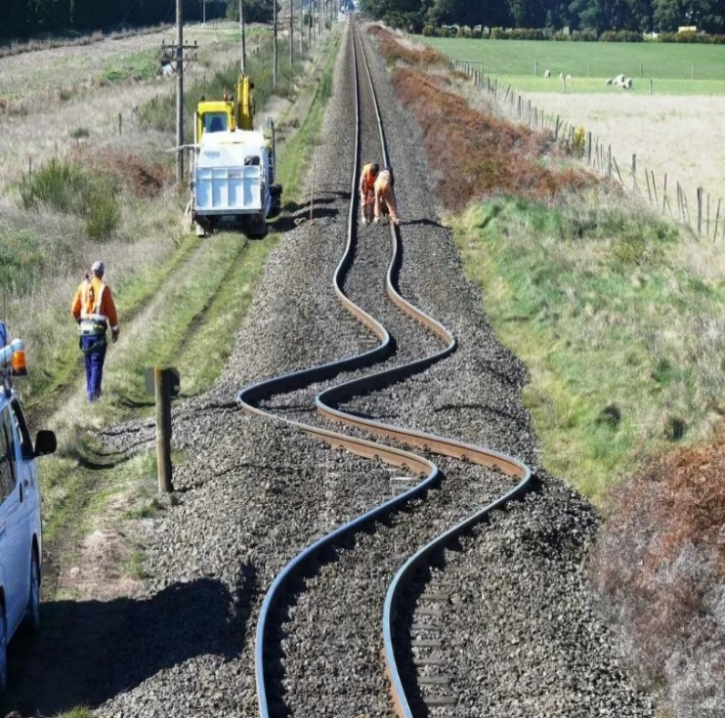

Figure 1.1 Buckling of Rail Track Caused by High Temperature

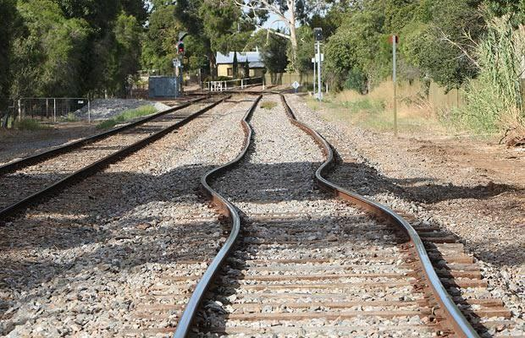

Figure 1.2 Buckling of Rail Track Caused by High Temperature

Chapter 1: Introduction
1.2 Project Objectives
The main objective of this project is to study the effect of high rail temperature on railway safety and propose an intelligent system capable of monitoring rail temperature and providing early thermal protection before reaching dangerous conditions. [1, 3, 8]
The project aims to achieve the following objectives:
- Designing a continuous rail temperature monitoring system using thermal sensors to provide real-time temperature measurement and detection. [13 ,14]
- Controlling rail temperature during high-temperature conditions to reduce thermal stress and prevent rail deformation or buckling. [3, 12]
- Reducing dependence on train speed reduction as the main solution for thermal expansion problems by introducing active cooling methods. [6, 19]
- Improving railway operational safety by minimizing the risk of track instability and train derailment caused by excessive thermal expansion. [6, 21]
- Integrating a Thermal Semaphore system with railway signaling to provide automatic warning indications according to rail temperature levels. [7, 11]
- Improving traffic flow and reducing train delays through better thermal monitoring and faster system response. [10, 27]
- Providing a scalable engineering model that can be integrated in the future with modern railway signaling systems such as ETCS and CBTC. [27, 38]

Chapter 1: Introduction
1.3 Importance of the Project
The importance of this project lies in addressing a real operational problem that directly affects the safety and efficiency of railway systems, rather than being a purely theoretical concept. Its significance can be summarized as follows: [1, 3 ,6]
- Contributing to the prevention of hazards caused by thermal buckling of railway tracks, which is one of the most critical failure modes in hot climates. [3 ,12]
- Reducing failures caused by excessive temperature rise, especially during summer seasons, when rail expansion is at its peak. [8, 12]
- Improving operational efficiency and minimizing delays resulting from train speed reduction during high-temperature conditions. [6 ,10]
- Supporting the transition toward smart railway systems that rely on automated monitoring instead of manual temperature measurement methods. [13, 14, 27]
- Reducing economic losses caused by train delays and operational disruptions, thereby improving overall railway performance. [10, 21]
- Enabling gradual implementation of the system in regions most exposed to high temperature conditions, ensuring practical scalability and real-world applicability. [19, 38]

Chapter 1: Introduction
1.4 Features of the Active Rail Cooling and Thermal Signaling System [ARCTSS]
The Active Rail Cooling and Thermal Signaling System [ARCTSS] provides several engineering and operational features that improve railway safety and operational efficiency under high-temperature conditions. [1, 3 ,6]
- Improving railway operational safety by reducing the possibility of rail buckling and track instability caused by excessive thermal expansion. [3, 12]
- Reducing the need for train speed restrictions during hot weather, allowing trains to operate closer to their normal design speed. [6, 10]
- Maintaining smoother railway traffic flow and minimizing delays caused by high rail temperature conditions. [10, 21]
- Supporting modern signaling systems such as ETCS and CBTC by improving operational continuity and train headway management. [27, 38]
- Providing early detection of abnormal temperature rise before reaching dangerous thermal limits. [13–14]
- Reducing accumulated thermal stress in rails, which helps increase the operational lifetime of railway tracks. [3 ,12]
- Minimizing sudden failures and reducing emergency maintenance require-ments during railway operation. [19 ,21]
- Allowing phased implementation of the system on critical railway sections without requiring full network installation. [19 ,38]
- Providing a flexible system design suitable for different railway track lengths and rail types. [12 ,14]
- Integrating railway track engineering with signaling systems to provide a unified thermal safety and operational control approach. [7 ,11]
- Improving the utilization of existing railway infrastructure without the need for constructing additional railway lines. [10 ,21]
- Reducing indirect economic losses caused by train delays, speed restric-tions, and operational interruptions. [6 ,10]

Chapter 1: Introduction
1.5 Design Theories
The design of modern engineering systems is based on scientific principles aimed at finding effective solutions to specific problems. The process begins with problem definition, followed by analysis of causes and effects, and evaluation of possible solutions to select the most suitable technical approach. [1 ,3 ,6]
In this project, the Engineering Design Process was applied to address the problem of high rail temperature and its impact on railway safety. The study focused on thermal expansion in Continuous Welded Rail (CWR) and its associated risks such as rail deformation and track buckling. [3 ,12]
The analysis showed that increased rail temperature generates internal compressive stresses that can destabilize the track and threaten safe train operation. [3 ,12 ,21]
Several solutions were examined, including passive cooling, water-based cooling, thermal control, and thermal signaling systems. After evaluation, the selected approach was the integration of active cooling with thermal signaling to improve safety and thermal protection. [6 ,10 ,27]
The design also considered key engineering factors such as ease of installation and maintenance, low operational cost, high reliability, and future scalability. [10 ,19]

1.5.1 Idea Selection Stage
Initial meetings were held to select a suitable graduation project topic based on innovation, feasibility, and educational value. Multiple ideas were discussed and evaluated through research and analysis. [1 ,3 ,6]
Chapter 1: Introduction
After careful consideration, a railway thermal safety system was selected due to its relevance to real operational challenges and its importance in improving railway safety and performance. [3 ,12 ,21]

1.5.2 Reason for Choosing the Idea
The project was chosen due to increasing operational problems in railway systems during high-temperature periods, which cause delays and speed restrictions affecting train operation and passenger service. [3 ,6 ,10]
High rail temperature leads to thermal expansion, which may cause instability and unsafe operating conditions. Additionally, high temperatures negatively affect signaling system performance. [7 ,11]
Therefore, the project focuses on a preventive solution based on continuous monitoring and early intervention before reaching critical thermal limits. [13–14]
The system integrates thermal monitoring directly with signaling, reducing reliance on manual inspection and operational decisions. [7 ,13]
Moreover, limitations of traditional systems highlight the need for intelligent solutions that improve safety, efficiency, and reliability in railway operations. [11 ,21]

Chapter 1: Introduction
1.6 Project Implementation Timeline
Table 1.1. Project Implementation Timeline

Outputs | Detailed Activities | Phase | Date | Week
Define project scope and final objectives | Study of rail thermal expansion problem, review of similar projects, defining project objectives | Problem study and analysis | 2026/2/7 | Week 1
Approved initial system concept | Drawing general system layout, identifying electronic and mechanical components, defining cooling cycle concept | Preliminary system design | 2026/2/14 | Week 2
Final engineering drawings | Designing cooling channels, calculating tank capacity, defining prototype dimensions | Detailed engineering design | 2026/2/21 | Week 3
All components available | Purchasing Arduino and sensors, pump and fan procurement, preparing rail and mechanical parts | Components  procurement and preparation | 2026/2/28 | Week 4
Ready electronic circuit | Sensor wiring, relay installation, initial circuit testing | Electronic circuit  implementation | 2026/3/7 | Week 5
Working control program | Writing thermal control code, defining threshold levels, testing system logic | Control system programming | 2026/3/14 | Week 6
Chapter 1: Introduction
Table 1.1. Project Implementation Timeline

Outputs | Detailed Activities | Phase | Date | Week
Completed prototype structure | Rail installation, cooling channel assembly, tank and pump installation | Prototype fabrication and assembly | 2026/3/28 | Week 7
Fully integrated system | Connecting pump with controller, testing cooling cycle, performance adjustment | Mechanical and  electronic integration | 2026/4/4 | Week 8
Documented experimental results | Temperature rise testing, response time measurement, data recording | Testing and  experimentation | 2026/4/11 | Week 9
Optimized stable system | Cooling efficiency analysis, system performance improvement | Results analysis and optimization | 2026/4/18 | Week 10
Final project draft ready | Writing chapters, inserting figures, formatting tables | Project documentation preparation | 2026/4/22 | Week 11
Project ready for defense | Final review, PowerPoint preparation, presentation practice | Final review and  defense preparation | 2026/6/10 | Week 12

Chapter 1: Introduction
1.7 Fundamentals of Railway Track Engineering
Railway Track Engineering is a key branch of railway engineering concerned with the design, construction, and maintenance of railway tracks to ensure safe and efficient operation. It focuses on the interaction between train loads and track components such as rails, sleepers, ballast, and fastening systems. [1–3]
Railway tracks are continuously subjected to mechanical and thermal stresses due to train movement and temperature variations, which may lead to deformation or track buckling if not properly controlled. [2 ,4]
The main track components—rails, sleepers, ballast, and fastening systems—work together to ensure stability, load distribution, and safe train movement, while regular maintenance and renewal are essential to preserve performance and reduce failures. [1 ,3 ,5]

1.7.1 Structural Components of Railway Tracks
Railway tracks consist of several structural components that ensure stability, load distribution, and safe operation: [1 ,3]
- Formation (Subgrade)
Provides a stable foundation for the track and ensures proper load distribution and drainage. [3–4]
2. Rails
Carry train loads and guide movement along the track. Modern flat-bottom rails are widely used due to their strength and maintainability. [2 ,5]
3. Sleepers
Support rails, maintain gauge, and distribute loads to the ballast. They are commonly made of concrete, steel, or wood. [1 ,3]
4. Fastening Systems
Secure rails to sleepers and prevent movement under dynamic loads. [2 ,5]

Chapter 1: Introduction
5. Ballast
A crushed stone layer that provides stability, drainage, shock absorption, and supports maintenance operations. [3–4 ,6]

1.7.2 Track Maintenance and Renewal
Track maintenance is essential to ensure safe operation and maintain track geometry and performance. [1 ,5]
It is classified into:
- Routine Maintenance: Immediate repair of defects such as misalignment or loose fastenings. [5]
- Periodic Maintenance: Scheduled adjustment and replacement of components to maintain performance. [5–6]
- Mechanical Maintenance: Use of specialized machines (e.g., tamping machines) to restore alignment and stability. [4]
- Track Renewal: Full replacement of track components when maintenance is no longer sufficient. [6]

Compatibility with ARCTSS System
The proposed ARCTSS system is designed to be compatible with railway maintenance operations. It uses detachable cooling channels fixed by clamps without permanent modification to rails or sleepers.
This allows:
- Easy removal during maintenance activities (e.g., tamping or replacement works)
- Quick reinstallation after maintenance
- No structural impact on track safety or integrity

Chapter 1: Introduction
1.8 Fundamentals of Railway Signaling Systems
Railway signaling systems are essential for ensuring safe train movement, preventing collisions, and regulating traffic. The railway line is divided into blocks, where only one train is allowed per section. [7–8]
Signaling systems have evolved from manual and mechanical systems to modern electrical and automated systems, improving safety and efficiency. [8–9]

1.8.1 Evolution of Signaling Systems
Signaling began with manual flags and lamps, then developed into mechanical systems with interlocking, followed by electrical and automated systems such as ATC and centralized control, which significantly improved safety and performance. [8–10]

1.8.2 Types of Signaling Systems
- Mechanical systems [historical use] [8]
- Electro-mechanical systems [hybrid stage] [9]
- Electrical and automatic systems [modern use] [10]
Modern systems rely on track circuits, automatic signals, and centralized control for efficient operation. [9–10]

1.8.3 Basic Signal Indications
Signal lights provide instructions to train drivers:
- Red: Stop [7]
- Yellow: Caution [7]
- Green: Proceed [7]

Chapter 2: Literature Review for Related Work

Chapter Two
Literature Review
for Related Work

Chapter 2: Literature Review for Related Work
2.1 Railway Thermal Expansion and Track Failure
Railway thermal expansion is one of the most critical challenges affecting modern railway systems, especially in hot climate regions such as Egypt. Large temperature variations cause changes in rail length and geometry, which may lead to loss of track stability and severe buckling failures. [1–2]
Studies show that continuously welded rails [CWR] are more susceptible to thermal stress accumulation compared to jointed rails due to the absence of expansion gaps. As a result, stresses are transferred directly into the rail structure. [2–3]
Rail failure is not only dependent on temperature but also on several contributing factors such as fastening quality, ballast condition, track alignment, and previous maintenance activities. [1 ,4]
Therefore, addressing this problem requires integrated solutions combining thermal monitoring, control systems, and active cooling, which is the concept adopted in this project. [3 ,5]

2.1.1 Thermal Expansion in Railway Rails
Thermal expansion is a physical phenomenon that occurs when materials expand due to an increase in temperature, causing an increase in atomic spacing and overall length. [2]
In railway rails, thermal expansion can be expressed using the following equation: [2–3]
ΔL=α×L×ΔT

Chapter 2: Literature Review for Related Work
Where:
• ΔL = change in length
• α = coefficient of thermal expansion of steel
• L = original rail length
• ΔT = temperature change
Since modern rails are tightly fixed using fastening systems, free expansion is restricted. As a result, thermal expansion is converted into internal stress [thermal stress] rather than physical elongation. [3–4]
Research indicates that:
• Below 40°C → relatively safe condition
• 45–50°C → stress begins to increase
• Above 55°C → critical condition
Therefore, controlling rail temperature is more important than only measuring it. [1 ,4]

2.1.2 Track Buckling and Rail Deformation
Buckling is the most dangerous result of thermal expansion, occurring when compressive forces exceed track resistance, causing sudden lateral displacement of the rail. [2–3]
Buckling commonly occurs in:
• Weak fastening areas
• Curves
• Recently maintained sections with poor ballast compaction
Main deformation types include:
Chapter 2: Literature Review for Related Work
- Lateral buckling
- Track misalignment
- Loss of geometric stability
These conditions may lead to:
• Train derailment
• Severe track damage
• Traffic interruption
Studies show that buckling risk increases significantly at temperatures ≥ 60°C, which highlights the importance of early detection systems rather than post-failure reaction. [3 ,5]

2.1.3 Methods of Reducing Thermal Stress in Railways
Several engineering methods have been developed to reduce thermal stress: [1 ,3]
- Stress Relieving
Rails are installed at a neutral temperature to ensure balanced stress distribution.
- Ballast Improvement
Increasing ballast density improves lateral resistance and reduces buckling risk.
- Fastening System Strengthening
Using high-torque clips and fasteners ensures stable rail fixation.

Chapter 2: Literature Review for Related Work
- Operational Control
Such as speed reduction or stopping trains during extreme heat conditions.
- Modern Active Systems
Including:
• Continuous thermal monitoring
• Active cooling systems
• Early warning systems
This project belongs to this advanced category of solutions. [4–5]

2.1.4 Importance of Stress Reduction in Railway Engineering
Reducing thermal stress is not optional but essential for railway safety. [1–2]
Its importance includes:
- Safety
Reducing buckling risk and preventing train accidents.
- Infrastructure Protection
High stress leads to:
• Rail wear
• Sleeper damage
• Ballast degradation
- Operational Efficiency
Stable tracks allow higher speeds and smoother operation.

Chapter 2: Literature Review for Related Work
- Cost Reduction
Preventing failures reduces maintenance costs significantly.
- Extended Track Life
Lower stress leads to longer lifespan of railway components. [3–4]
2.1.5 Compatibility with Track Maintenance Operations
The proposed system is designed to be fully compatible with existing railway maintenance procedures. [4–5]
1. No Interference with Tamping Operations
Cooling channels are installed using clamp-based systems, allowing easy removal during maintenance.
2. Protection of Track Components
The system does not affect:
• Sleepers
• Ballast
• Fastening systems
3. Maintainability
• Easy access to components
• Simple replacement without line interruption
4. Compliance with Technical Standards
The system supports:
• Temperature monitoring
• Speed reduction protocols
• Emergency shutdown procedures
Chapter 2: Literature Review for Related Work
5. Integration with Existing Systems
The system does not replace traditional methods but:
• Enhances them
• Improves efficiency
• Shifts from reactive to proactive maintenance

2.2 Railway Monitoring and Inspection Systems
With the advancement of railway systems and increasing train speeds, modern monitoring systems have become essential for detecting faults before they occur (preventive monitoring), as traditional inspection methods are no longer sufficient due to infrastructure complexity and higher operational loads. [1–2]
Modern systems rely on thermal sensors, data acquisition units, real-time processing, and decision-making algorithms to ensure continuous and accurate monitoring. [2–3]
Thermal monitoring is considered one of the most important safety technologies, as it can detect abnormal temperature rise and early-stage rail failures. Infrared thermography also provides non-contact measurement, wide area coverage, and real-time results, making it a key tool in railway safety. [3–4]

2.2.1 Thermal Semaphore Concept
The thermal semaphore is an advanced signaling approach where signal status is based on rail temperature rather than only train position. [3]

Chapter 2: Literature Review for Related Work
It operates by measuring temperature, processing data in a control unit, and converting results into visual signals (green, yellow, red). [3 ,5]
This approach integrates thermal monitoring with signaling systems, shifting railway control from position-based operation to condition-based monitoring. [2–3]
It provides automatic decision-making, reduces human dependency, and ensures faster response to temperature changes, making the system a smart safety mechanism rather than a simple signaling method. [3 ,5]

2.2.2 Manual vs Automatic Rail Temperature Monitoring Systems
Manual Systems:
Traditional monitoring depends on manual temperature measurement and periodic inspection. [1]
Limitations include non-continuous monitoring, high human dependency, low accuracy, and lack of real-time response. [1–2]
Automatic Systems:
Modern systems use sensors, real-time data transmission, and automated analysis. [2–3]
They provide continuous monitoring, higher accuracy, faster response, and improved safety by reducing human error. [3–4]
These systems are integrated with alarms, control units, and communication networks, making railways part of smart infrastructure. [4–5]

Chapter 2: Literature Review for Related Work
2.2.3 Developments and Global Trends in Monitoring Systems
Modern railway monitoring has evolved significantly, with key trends including artificial intelligence for prediction, IoT for connectivity, big data analysis, and predictive maintenance strategies. [2–3]
These technologies enable a shift from reactive maintenance to failure prediction, improving system reliability and safety. [3–4]
Current systems rely on multi-sensor networks, real-time monitoring, and remote control to enhance decision-making efficiency. [4–5]

2.2.4 Infrared and Smart Thermal Monitoring Technologies
Infrared thermography is a key technology in modern railway monitoring. It detects thermal radiation emitted from objects and converts it into thermal images for analysis. [4]
It offers non-contact measurement, fast operation, wide-area monitoring, and early fault detection capabilities. [4]
Applications include rail temperature monitoring, crack detection, material analysis, and infrastructure inspection. [4–5]
Smart monitoring systems also use thermal cameras, wireless sensors, cloud platforms, and AI-based analysis to collect and process data in real time. [4–5]
These technologies enable full-section railway monitoring and instant decision support, significantly improving safety and efficiency. [4]

Chapter 2: Literature Review for Related Work
Integration with the Proposed System
The proposed ARCTSS integrates thermal monitoring, active cooling, and thermal signaling into a single unified system, combining monitoring, control, cooling, and signaling functions. This makes it a fully integrated railway safety solution rather than a single-function system. [2 ,5]

2.3 Rail Cooling Technologies and Thermal Control Methods
With the increasing impact of high temperatures on railway systems, thermal control has become a critical safety requirement, especially in hot-climate countries such as Egypt. Recent studies focus on developing cooling technologies that reduce thermal expansion and prevent rail buckling. [1 ,3 ,21]
Rail cooling is based on the principle of maintaining rail temperature below critical limits to ensure structural stability. [3 ,12 ,21]
Passive Cooling Methods:
Passive techniques do not require external energy, such as reflective coatings that reduce solar absorption, ballast optimization to improve heat dissipation, and natural ventilation to enhance convection. These methods are low-cost but have limited effectiveness. [12 ,21]
Active Cooling Methods:
Active systems use mechanical components to control temperature, including water spray systems (high efficiency but high consumption), closed-loop cooling systems (high efficiency with pumps and heat exchangers), forced air cooling (simple but less effective), and phase change materials (high heat storage but complex and costly). [3 ,21]
Chapter 2: Literature Review for Related Work
Thermal Control Systems:
Thermal safety depends not only on cooling but also on intelligent control systems that monitor temperature, compare it with thresholds, and activate cooling or alarms automatically. [3 ,21]
Modern Trends:
Recent developments integrate AI, IoT, and smart monitoring systems to create predictive and intelligent thermal control frameworks. [1 ,3 ,21]

Link with Proposed Project
The proposed system integrates active cooling, closed-loop circulation, thermal monitoring, and signaling into a unified safety system. Instead of only reducing temperature, it prevents critical conditions through automatic decision-making and links thermal status directly to signaling, forming a predictive smart system. [12 ,21]

2.4 Sensors and Control Systems in Railway Applications
Sensors and control systems are essential in modern railway infrastructure, enabling continuous monitoring and automatic response. They replace traditional manual inspection methods, improving accuracy, safety, and reliability. [1 ,3 ,21]
The ARCTSS system integrates temperature sensors, infrared sensors, and Arduino-based control units to form an intelligent thermal monitoring and cooling framework. [1 ,3 ,21]

Chapter 2: Literature Review for Related Work
2.4.1 Temperature Sensors in Industrial Applications
Temperature sensors are widely used for accurate thermal measurement. Thermocouples are suitable for high temperatures, RTDs provide high accuracy, while semiconductor sensors such as DS18B20 are widely used in prototype systems due to their simplicity and cost-effectiveness. [3 ,12 ,21]
In this project, the DS18B20 sensor continuously monitors rail temperature and sends data to the control unit for automatic decision-making. [3 ,12]

2.4.2 Infrared Sensors and Non-Contact Measurement
Infrared sensors detect thermal radiation without physical contact, enabling fast and continuous monitoring. They are useful for detecting hot spots and monitoring railway components during operation. [1 ,3 ,21]
In ARCTSS, IR sensors can act as an additional monitoring layer to improve accuracy and system reliability. [1 ,3 ,21]

2.4.3 Arduino-Based Control Systems
Arduino is a widely used microcontroller platform capable of reading sensors and controlling outputs based on programmed logic. [3 ,21]
In this system, Arduino processes temperature data and controls pumps, fans, heaters, LEDs, and alarms according to predefined thermal thresholds. It provides a low-cost and flexible solution suitable for prototype development.

Chapter 2: Literature Review for Related Work
2.4.4 Automation in Safety and Monitoring Systems
Automation enhances railway safety by reducing human dependency and improving response speed. It integrates sensors, controllers, and actuators to enable continuous monitoring and automatic control. [1 ,3 ,21]
In ARCTSS, automation is based on temperature levels:
- Normal → Green signal
- Warning → Yellow signal + partial cooling
- Critical → Red signal + full cooling
This transforms the system into an intelligent thermal safety framework rather than a simple monitoring system. [1 ,3 ,21]

2.5 Related Research and Previous Studies
The literature review highlights developments in thermal expansion, rail buckling, monitoring systems, cooling technologies, and signaling integration in railway applications. It also identifies the research gap addressed by this project. [1 ,3 ,6]
International studies have explored solutions such as Phase Change Materials (PCM) and automated water spray systems to reduce rail temperature and mitigate buckling risks. [3 ,12] In Egypt, railway systems still rely mainly on manual monitoring and speed restrictions during high-temperature conditions. [19 –20]
The ARCTSS project builds upon these studies by integrating active cooling, thermal signaling, and automatic control into a unified system suitable for hot-climate railway environments. [22]
Chapter 2: Literature Review for Related Work
2.5.1 Thermal Expansion and Track Buckling Studies
Research confirms that thermal expansion in Continuous Welded Rail (CWR) systems is a major safety issue in hot climates. [3 ,12]
When rail temperature exceeds approximately 50°C, thermal stress increases significantly, and above 60°C the risk of buckling becomes critical. [3 ,21] Structural weaknesses such as poor fastenings, degraded sleepers, and ballast conditions further increase instability. [12 ,21]

2.5.2 Railway Maintenance and Stress Control Studies
Studies propose mitigation methods such as neutral temperature adjustment, ballast reinforcement, concrete sleepers, and tamping operations to improve track stability. [10 ,21]
Many railway systems also apply speed restrictions during high-temperature conditions. However, these methods are mainly reactive rather than predictive. [3 ,12]

2.5.3 Thermal Monitoring Systems
Modern research includes manual inspection, fixed sensors, and IoT-based real-time monitoring systems. [1 ,3]
Although these systems improve detection accuracy, most focus only on monitoring without integrating active cooling or automatic thermal response mechanisms. [21]

Chapter 2: Literature Review for Related Work
2.5.4 Infrared and Smart Monitoring Technologies
Infrared thermography is widely used for detecting hot spots and rail defects. Advanced systems also apply AI and predictive analytics for early fault detection. [3 ,21]
However, these systems are often expensive and difficult to deploy across large railway networks. [10 ,21]

2.5.5 Railway Cooling Technologies
Cooling technologies remain less developed compared to monitoring systems. Existing methods include water spraying, reflective coatings, and passive ventilation. [6 ,10 ,21]
These methods provide limited and environment-dependent cooling, highlighting the need for active and continuous cooling systems. [3 ,21]

2.5.6 Integration with Signaling Systems
Modern research focuses on integrating monitoring with signaling systems such as CTC and ATC to improve operational efficiency. [1 ,6]
However, most systems do not directly link rail temperature with signaling behavior, limiting real-time safety response. [12 ,21]

Chapter 2: Literature Review for Related Work
2.5.7 Research Gap and Project Contribution
Existing systems are mainly passive or reactive and lack full integration between cooling, monitoring, and signaling. [3 ,8 ,19]
The ARCTSS project addresses this gap by combining active cooling, real-time thermal monitoring, and automatic signaling into a single integrated safety system capable of continuous operation and predictive response. [7 ,11 ,22]
Unlike conventional approaches, it introduces a dual-layer safety mechanism that both reduces temperature and immediately communicates rail status through a thermal semaphore system, ensuring continuous safety even in case of partial system failure. [23 ,27]
Table 2.1. Comparison between Traditional Methods and the Proposed ARCTSS

Feature | Traditional Methods (Manual) | Passive Cooling Systems | Proposed ARCTSS System
Response Type | Reactive (Slow) | Passive (Limited) | Proactive (Instant)
Cooling Efficiency | None | Low | High (Active Liquid Cooling)
Human Intervention | 100% Required | Not Required | 0% (Fully Automated)
Signaling Link | Manual Communication | None | Direct Automated Link
Data Accuracy | Low (Human Error) | No Data | High (Precision Sensors)
Train Speed | Must be reduced | Limited effect | Maintained (Reduces Delays)
Chapter 3: Problem Under Consideration [ARCTSS Context[

Chapter Three
Problem Under Consideration
[ARCTSS Context]

Chapter 3: Problem Under Consideration [ARCTSS Context[
3.1 Current Field Procedures for Rail Temperature Monitoring in Egyptian Railways
In Egyptian Railways, rail temperature monitoring is carried out according to technical instructions issued by the Infrastructure Sector and the Central Administration of Track Engineering to ensure safety during high-temperature periods, especially in summer. [1 ,3]
High rail temperatures in continuously welded rails (CWR) lead to thermal expansion and internal stresses, which may result in rail deformation and track buckling, representing a major safety risk. [3 ,12]
Current procedures rely mainly on manual temperature measurement, where a technician places a thermometer on the rail head for 10–15 minutes to obtain an accurate reading while minimizing direct solar influence. [1 ,10]
Guidelines indicate that when ambient shaded temperature reaches about 40°C, rail temperature may exceed 50°C due to solar absorption. In such cases, precautionary measures are applied to reduce risk. [3 ,21]
At temperatures around 50–55°C, maintenance teams perform continuous inspection, ballast reinforcement may be applied, and train speeds are reduced (approximately 90 km/h for passenger trains and 60 km/h for freight trains). [1 ,12]
In critical zones such as curves, weak fastenings, or unstable welded sections, stricter measures may include further speed reduction or suspension of certain maintenance operations to avoid instability. [3 ,21]
These procedures indicate that the current system is mainly manual and reactive, which may delay response to sudden temperature increases. [10 ,12]
Therefore, there is a strong need for intelligent systems based on continuous monitoring and automatic thermal control, such as the proposed ARCTSS, which provides real-time monitoring and preventive action before reaching critical conditions. [1 ,21]
Chapter 3: Problem Under Consideration [ARCTSS Context[
3.2 Limitations of Existing Systems
Current railway temperature monitoring systems rely mainly on manual inspection and periodic measurements, which limits real-time monitoring and fast response capability. [1 ,10]
These systems depend heavily on human intervention, increasing the risk of delayed detection of sudden temperature rises or critical thermal conditions. [3 ,12]
They also lack automatic corrective actions, as they only provide readings without integrating cooling or control mechanisms. [10 ,21]
Another limitation is the absence of integration between thermal monitoring and signaling systems, which reduces the ability to respond dynamically to thermal hazards. [12 ,21]
Overall, these systems are reactive rather than preventive, creating a safety gap under extreme weather conditions. [1 ,3]

3.3 Safety Risks Due to Thermal Expansion
Thermal expansion in continuously welded rails (CWR) is a major safety risk, as restricted expansion leads to internal stress accumulation. [3 ,12]
When rail temperature exceeds safe limits, compressive stresses increase, which may cause lateral buckling and permanent deformation of track geometry. [3 ,21]
This can lead to serious hazards such as derailment, track misalignment, and sudden rail failure. [12 ,21]
The risk is higher in weak ballast areas, poor fastening systems, and poorly maintained tracks. [10 ,21]
Chapter 3: Problem Under Consideration [ARCTSS Context[
Extreme summer temperatures can push rail conditions close to critical instability, where minor disturbances may trigger buckling. [3 ,12]
Therefore, thermal expansion is a direct safety threat requiring continuous monitoring and active control rather than manual inspection alone. [1 ,21]

3.4 Track Buckling and Rail Deformation Analysis
Track buckling is the most dangerous result of thermal expansion, occurring when compressive stresses exceed the lateral resistance of the track structure. [3 ,12]
It is strongly associated with continuously welded rails where expansion joints are absent, causing stress accumulation along the rail. [3 ,21]
Buckling is more likely in weak fastenings, curved sections, and poorly compacted ballast areas. [12 ,21]
Main deformation types include lateral buckling, track misalignment, and loss of geometric stability. [3 ,12]
These failures can lead to derailment, track collapse, and railway service interruption. [10 ,21]
Studies show that the risk increases significantly when rail temperature approaches or exceeds 60°C. [3 ,21]
Therefore, modern safety systems focus on early detection and prevention rather than post-failure reaction. [1 ,12]

Chapter 3: Problem Under Consideration [ARCTSS Context[
3.5 Need for an Intelligent Thermal Safety System (ARCTSS Justification)
Increasing extreme temperatures highlight the need for a shift from manual monitoring to intelligent automated thermal safety systems. [1 ,3]
Existing approaches are mainly manual and reactive, making them insufficient for rapid temperature changes across railway networks. [3 ,10]
This creates a gap between detection and response, where dangerous conditions may occur before corrective actions are taken. [12 ,21]
Additionally, lack of integration between monitoring, cooling, and signaling reduces overall system effectiveness. [10 ,21]
Modern research emphasizes predictive and preventive systems capable of real-time monitoring and automatic response. [1 ,12]
Therefore, the ARCTSS system is proposed as an intelligent solution that integrates real-time monitoring, automatic cooling, and signaling to ensure immediate response to thermal risks. [3 ,21]
This transforms railway safety from a reactive manual process into an automated predictive protection system designed to prevent failures before they occur. [1 ,21]

Chapter 4: Method of Solution [ARCTSS Implementation]

Chapter Four
Method of Solution
[ARCTSS Implementation]

Chapter 4: Method of Solution [ARCTSS Implementation]
4.1 System Overview [ARCTSS Concept]
The Active Rail Cooling and Thermal Signaling System (ARCTSS) is an integrated prototype designed to study and simulate the thermal behavior of railway tracks under high temperature conditions by combining monitoring, cooling, and signaling into a unified safety system. [1 ,2]
The system is an academic experimental model that translates thermal expansion and rail stress principles into a practical setup for evaluating performance under controlled conditions. [1 –3]
Its main concept is continuous temperature monitoring with real-time data processing and automatic activation of cooling and signaling when predefined thresholds are exceeded, forming a closed-loop safety system. [2 ,4]
The rail model is a scaled conductive structure (iron or aluminum) mounted on an insulated base to simulate realistic heat transfer behavior. [1 ,6]
The system operates through four stages: temperature sensing, microcontroller data processing, real-time decision making, and activation of cooling and signaling units. [3 ,5]
Under normal conditions, the system remains idle with a green signal. In warning conditions, partial cooling is activated with a yellow signal, while in critical conditions full cooling is triggered with a red alert signal. [2 ,5]
The cooling mechanism works as a closed-loop cycle where heat is absorbed from the rail, dissipated through a cooling unit, and recirculated to maintain thermal balance. [2 ,7]
The control system is based on a microcontroller that processes sensor data and coordinates cooling and signaling actions. [5 ,8]
Chapter 4: Method of Solution [ARCTSS Implementation]
ARCTSS is designed for potential integration with modern railway infrastructure and smart monitoring systems. [4 ,9]
The system shifts railway safety from reactive maintenance to a predictive model aimed at preventing thermal failures before they occur. [3 ,9]
Overall, it enhances railway safety by reducing manual inspection, increasing response speed, and providing a scalable model from laboratory prototype to real-world applications. [2 ,5]
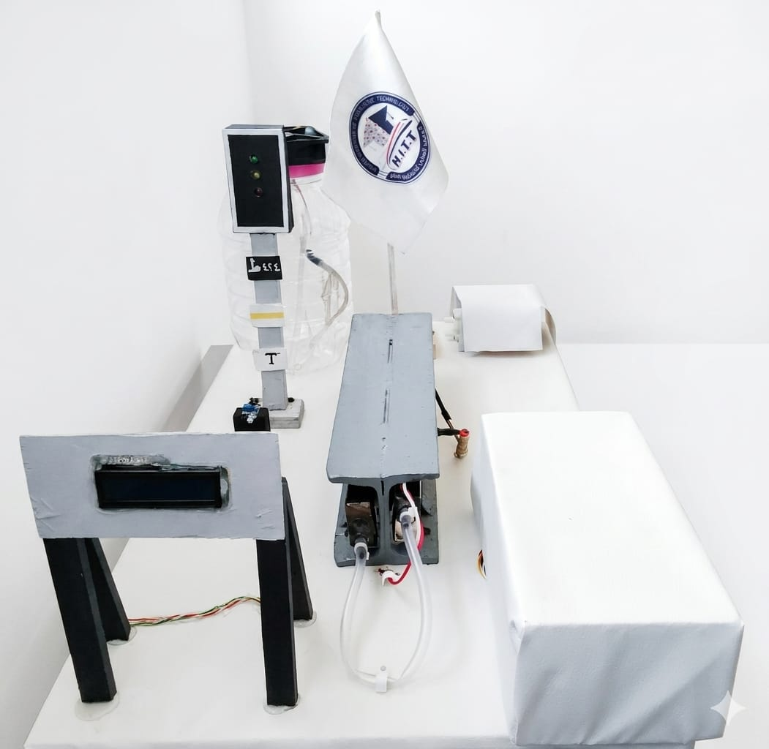
Figure 4.1. Prototype

4.2 Prototype Design [Academic Model]
The prototype represents the first practical implementation stage of ARCTSS, where the theoretical concept is transformed into a scaled experimental model used to validate system performance and thermal behavior under controlled conditions. [1 –2]

Chapter 4: Method of Solution [ARCTSS Implementation]
The design aims to simulate rail thermal expansion while integrating cooling and signaling mechanisms to evaluate the effectiveness of the proposed safety system. [1 ,3]
The model is designed to be simple, low-cost, easily assembled, and scalable for future development while combining mechanical, thermal, and electronic subsystems into one integrated platform. [2 ,4]

4.2.1 Rail Model Structure
The rail model is a metallic structure made from a thermally conductive material such as iron or aluminum to simulate real railway heat absorption behavior. [1 ,5]
It is mounted on a stable MDF wooden base to ensure mechanical stability and reduce vibration during experiments. [5 –6]
The design allows direct exposure of the rail surface for accurate temperature measurement and controlled heating to simulate real environmental conditions. [2 ,5]
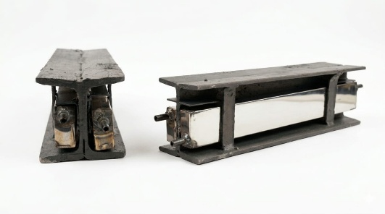

Figure 4.2. Rail Model

Figure 4.3. Wooden Base

Chapter 4: Method of Solution [ARCTSS Implementation]
4.2.2 Cooling Channels Design
The cooling system is based on a closed-loop circulation mechanism in which a coolant continuously flows to absorb and transfer heat away from the rail. [3 ,7]
Plastic or silicone tubes are used as cooling channels, connected to a small water pump and a reservoir tank to ensure continuous fluid movement. [7 –8]
The channels are fixed along the rail using L-shaped brackets to maintain thermal contact while allowing easy installation and removal. [6 ,8]
The coolant absorbs heat from the rail, returns to the tank, is cooled, and then recirculated to maintain continuous thermal regulation. [3 ,7]

4.2.3 Sensor Installation
A digital temperature sensor such as DS18B20 is used to measure rail temperature in real time with sufficient accuracy for experimental purposes. [4 –5]
The sensor is mounted directly on the rail surface using thermal paste to ensure proper heat transfer and accurate readings. [5 ,9]
It continuously sends temperature data to the control unit, enabling real-time monitoring and system decision-making. [3 ,5]
Proper placement is essential to ensure the sensor detects critical temperature zones while avoiding insulation errors or unstable readings. [4 ,9]

Chapter 4: Method of Solution [ARCTSS Implementation]
4.2.4 Thermal Semaphore System
The thermal semaphore system is used to visually indicate the operational state of the rail using a simple LED-based signaling system. [2 ,4]
It consists of green, yellow, and red LEDs representing safe, warning, and danger conditions respectively. [4 ,6]
In safe conditions, the green LED remains active, while rising temperatures trigger warning states with yellow indication and flashing signals. [3 ,6]
When critical temperature thresholds are exceeded, the red LED is activated to indicate danger and trigger cooling response. [2 ,4]
This system simplifies monitoring and provides immediate visual feedback similar to real railway signaling systems. [6 ,9]

4.2.5 Electrical Connections
The electrical system integrates all components through an Arduino-based control unit responsible for processing sensor data and controlling outputs. [4 –5]
The system includes temperature sensors, relay modules, LEDs, a pump, and a regulated power supply connected through organized wiring for stable operation. [5 ,8]
The Arduino reads temperature data, processes it using predefined thresholds, and activates cooling systems or signaling outputs accordingly. [3 ,5]

Chapter 4: Method of Solution [ARCTSS Implementation]
Relays are used to control high-power components such as pumps, while LEDs represent system status indicators in real time. [4 ,8]
Proper electrical insulation and wiring organization are essential to ensure system safety and prevent short circuits during operation. [5 ,8]

4.3 Proposed Real System [ARCTSS]
The proposed real system represents the industrial-scale development of the ARCTSS prototype, where the concept is transformed into a fully operational railway safety solution intended for real track implementation. [1 –2]
The system aims to continuously regulate rail temperature, prevent thermal conditions from reaching critical limits, reduce the risk of track buckling, and enhance overall railway operational safety. [1 ,3]
It is based on the integration of four main subsystems: industrial cooling, thermal monitoring, centralized control, and signaling system integration. [2 ,4]

4.3.1 Industrial Cooling Channels
The industrial cooling channels are responsible for direct heat extraction from the rail through continuous coolant flow along the rail structure. [1 ,5]
They are designed using metallic materials such as aluminum or stainless steel and installed along the rail web or rail foot to maximize thermal contact efficiency. [5 –6]
The system is fixed using heavy-duty clamps without interfering with sleepers, fastening systems, or maintenance operations. [2 ,6]
The coolant absorbs heat from the rail and transfers it to the central cooling system for further processing and temperature reduction. [3 ,5]

Chapter 4: Method of Solution [ARCTSS Implementation]
4.3.2 Cooling Plant for Coolant
The cooling plant serves as the central thermal regulation unit responsible for reducing the temperature of the circulating coolant before re-injection into the system. [1 ,4]
It consists of an industrial storage tank, high-capacity pumps with speed control [VFD], and a heat exchanger system for efficient heat rejection. [4 ,7]
Air-cooled heat exchangers are preferred due to their suitability for hot climates and reduced infrastructure requirements. [5 ,7]
The coolant typically consists of a mixture of propylene glycol and deionized water to ensure thermal stability and corrosion resistance. [3 ,7]
The system operates in a closed loop where heated coolant is cooled in the plant and continuously recirculated to maintain stable rail temperature. [2 ,5]

4.3.3 Real Thermal Monitoring System
The thermal monitoring system acts as the core sensing layer of the system, responsible for real-time measurement and analysis of rail temperature conditions. [1 ,3]
It includes distributed temperature sensors installed directly on the rail and infrared sensors used for non-contact thermal detection in critical zones. [3 ,6]
Industrial controllers such as PLC units process sensor data and transmit it to a centralized monitoring center through communication networks like fiber optics or wireless systems. [4 ,8]
The system enables continuous monitoring, data logging, and real-time alerts to detect abnormal temperature rises before reaching hazardous levels. [2 ,4]
Unlike traditional manual inspection methods used in some railway systems, this approach provides continuous and automated monitoring capabilities. [3 ,8]

Chapter 4: Method of Solution [ARCTSS Implementation]
4.3.4 Integration with Railway Signaling System
The system is directly integrated with railway signaling infrastructure to convert thermal conditions into operational safety decisions. [1 ,4]
Temperature data is translated into signaling commands that control train movement through green, yellow, and red signal states. [2 ,6]
Under normal conditions, the system allows regular train operation with a green signal, while warning conditions trigger reduced operation and yellow signaling. [3 ,6]
In critical conditions, the system activates red signals, initiates full cooling operation, and can communicate with centralized traffic control systems to reduce train speed or restrict movement. [4 ,8]
This integration connects ARCTSS with modern railway systems such as CTC and ATC, enabling coordinated safety management across the network. [5 ,8]

4.3.5 Maintenance Compatibility
To ensure that the ARCTSS system does not obstruct routine track maintenance (such as tamping or rail grinding), the cooling channels are designed as modular units. These units are attached using quick-release clamps that allow maintenance crews to detach the cooling segments in minutes before the passage of maintenance machinery and reattach them easily afterward [6 ,31].
4.4 System Components
The ARCTSS prototype system is built from integrated mechanical, electrical, and control components designed to simulate real-time railway thermal monitoring and active cooling behavior. Each component contributes to sensing, processing, actuation, and system visualization under different thermal conditions.
Chapter 4: Method of Solution [ARCTSS Implementation]
[1] The control unit is implemented using an ATmega328P microcontroller mounted on a custom PCB board rather than a standard Arduino UNO. It performs real-time data processing, executes control logic, and manages system operations including cooling, alarms, and signaling. This design improves system stability and reflects a more realistic industrial implementation. [14 ,25]

[1] The control unit [Arduino UNO] acts as the main processing core of the system. It receives real-time input signals from sensors, processes temperature data, and executes control logic to manage cooling,
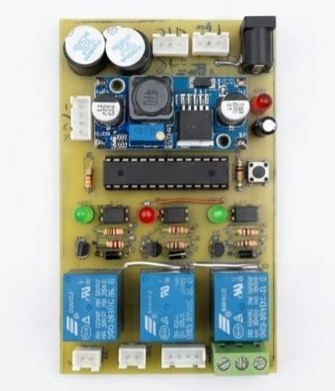
alarms, and signaling operations. It enables automatic decision-making for all system states. [14 ,25]
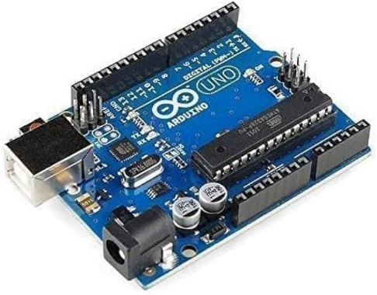

Figure4.5.BCP

Figure 4.4. Arduino UNO



Figure 4.6. Atmega328p Microcontroller

Chapter 4: Method of Solution [ARCTSS Implementation]
[2] The temperature sensor [DS18B20] is a high-accuracy digital sensor used to measure rail temperature continuously. It provides stable readings using a one-wire communication protocol, ensuring precise monitoring of thermal variations along the rail model. [13 ,24]
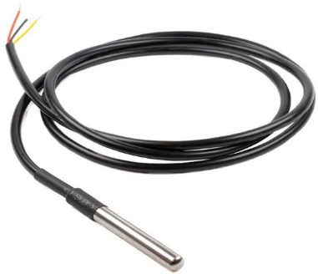

Figure 4.7. Temperature Sensor (DS18B20)

[3] The infrared sensor is used to detect the presence and movement of a simulated train passing over the rail. It enhances system realism by
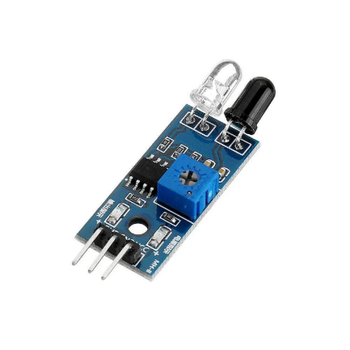
linking thermal response with train activity and triggering operational changes when movement is detected. [16]

Figure 4.8. Infrared Sensor

Chapter 4: Method of Solution [ARCTSS Implementation]
[4] The relay module acts as an electrical switching interface between the low-voltage control unit and high-power components such as pumps, heaters, and fans. It ensures electrical isolation and safe operation of the system. [28 –29]
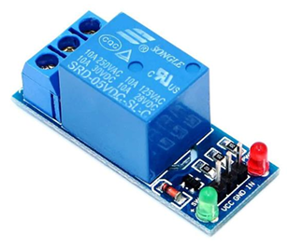

Figure 4.9. Relay Module

[5] The pump is a small circulation device responsible for moving coolant through the closed-loop system. It maintains continuous fluid flow between the tank and cooling channels to simulate industrial cooling behavior. [26 ,34]

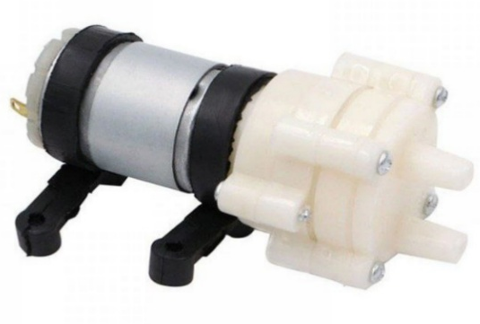

Figure 4.10. Pump

Chapter 4: Method of Solution [ARCTSS Implementation]
[6] The cooling fan assists in heat dissipation by increasing airflow around the system. It improves the efficiency of thermal reduction by accelerating heat exchange from the coolant and surrounding components. [17 ,34]
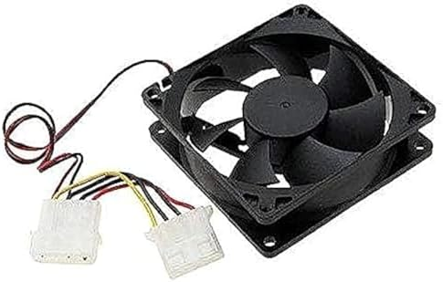

Figure 4.11. Cooling Fan

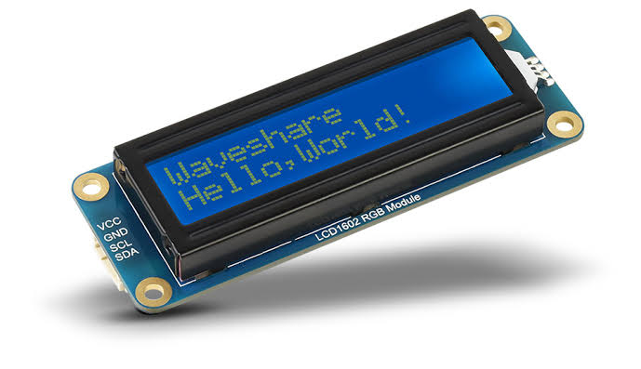
[7] The LCD display [16×2] provides real-time system feedback, including temperature values and operational status [safe, warning, danger]. It enhances monitoring and makes system behavior easily observable during testing. [24 ,28]

Figure 4.12.LCD display

[8] The buzzer is an audio warning device that activates during dangerous thermal conditions. It provides immediate sound alerts in addition to visual signaling for improved safety response. [7 ,11]
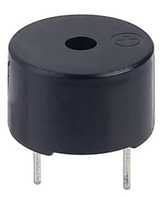

Figure 4.13. Buzzer

Chapter 4: Method of Solution [ARCTSS Implementation]
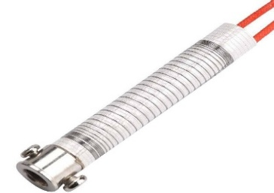
[9] The heating coil is used as a controlled heat source to simulate real railway thermal loading conditions. It allows testing of system response under rapid temperature increases. [34 –35]

Figure 4.14. Heating Coil

[10] The tank and hoses form a closed-loop circulation system for coolant storage and transport. The tank stores the fluid, while hoses transfer it between system components ensuring continuous flow. [17 ,26]

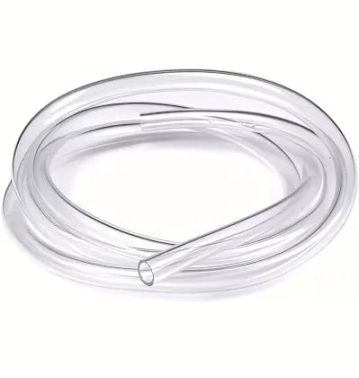

Figure 4.15. Hoses

Figure 4.16. Tank

[11] The rail steel model represents the physical railway track used for thermal testing. It acts as the main structure where heat is applied and cooling effects are evaluated. [1 –2]
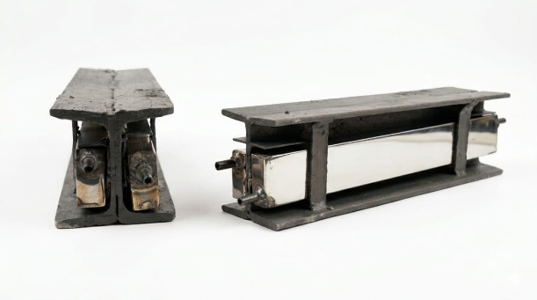
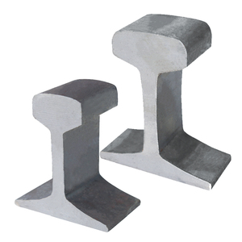

Figure 4.17. Rail

Figure 4.18. Rail Model

Chapter 4: Method of Solution [ARCTSS Implementation]
[12] The cooling channels are metallic ducts fixed along the rail structure to maximize heat transfer between the rail and circulating coolant. They provide high thermal conductivity and efficient heat absorption. [12 ,17]
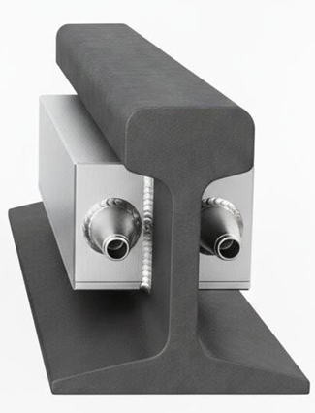

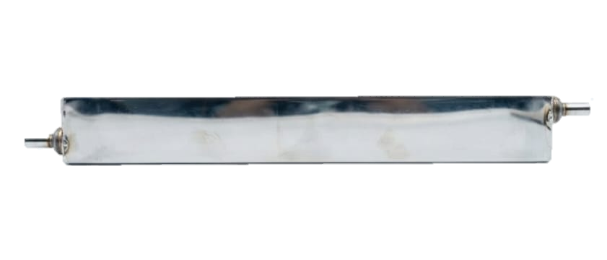

Figure 4.19. Cooling Channels

Figure 4.20. Cooling Channels Fixed to the Rail

[13] The L-shape support angles are mechanical fixing elements used to secure cooling channels onto the rail structure. They provide mechanical stability and reduce vibration during operation. [31]
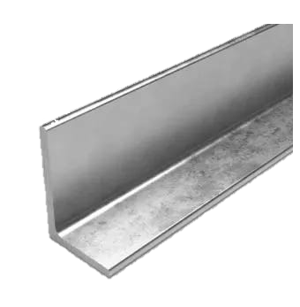

Figure 4.21. L-Shape Support Angles

Chapter 4: Method of Solution [ARCTSS Implementation]
[14] The power supply unit provides regulated electrical power for all system components. It ensures stable voltage distribution and includes protection and backup features for continuous operation. [29 ,10]


Figure 4.22. Power Supply

[15] The semaphore signal system is a three-color LED indicator [green, yellow, red] used to visually represent the thermal condition of the rail. It provides immediate safety status feedback. [7 –8]



Figure 4.23. Semaphore Signal

Chapter 4: Method of Solution [ARCTSS Implementation]
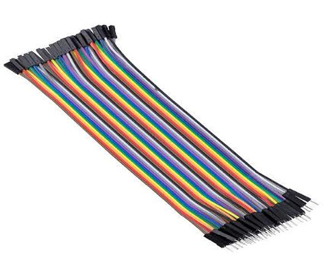
[16] The electrical wires and connectors form the communication and power distribution network of the system. They ensure proper signal transmission between all components. [13 ,28]

Figure 4.24. Electrical Wires

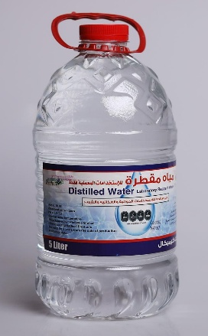
[17] The coolant is the working fluid responsible for absorbing and transferring heat from the rail through the cooling loop. It is selected for thermal stability, safety, and high heat transfer efficiency. [34 ,17]

Figure 4.25. Coolant

4.5 Datasheets and Specifications [2.4]
This section presents the technical datasheets and specifications of the components used in the ARCTSS prototype system. These specifications ensure compatibility between system elements and guarantee reliable performance under operating conditions.

Chapter 4: Method of Solution [ARCTSS Implementation]
[1] Microcontroller Unit [ATmega328P]
The microcontroller acts as the central processing unit responsible for executing control algorithms and managing all system operations [14].
Table 4.1. Microcontroller Technical Specifications

Parameter | Value
Operating Voltage | 5V
Clock Speed | 16 MHz
Flash Memory | 32 KB
SRAM | 2 KB
Digital I/O Pins | 14
Analog Inputs | 6
Communication | UART / I2C / SPI
Table 4.2. Microcontroller Pin Configuration

Pin | Function
VCC | Power Supply
GND | Ground
Digital Pins | Control Signals
Analog Pins | Sensor Inputs

Chapter 4: Method of Solution [ARCTSS Implementation]
[2] Temperature Sensor [DS18B20]
A high-precision digital sensor used for continuous rail temperature monitoring [13].
Table 4.3. Temperature Sensor Technical Specifications

Parameter | Value
Operating Voltage | 3.0 – 5.5V
Temperature Range | -55°C to +125°C
Accuracy | ±0.5°C
Resolution | 9–12 bit
Interface | One Wire

Table 4.4. Temperature Sensor Pin Configuration

Pin | Function
VCC | Power
GND | Ground
DATA | Signal

[3] Infrared Sensor [IR Sensor]
Used to detect object movement simulating train passage [16].

Chapter 4: Method of Solution [ARCTSS Implementation]
Table 4.5. IR Sensor Technical Specifications

Parameter | Value
Operating Voltage | 3.3 – 5V
Output Type | Digital
Detection Range | 2 – 30 cm
Table 4.6 IR Sensor Pin Configuration

Pin | Function
VCC | Power
GND | Ground
OUT | Signal Output

[4] Relay Module [5V]
Provides electrical isolation and switching for high-power devices [28].
Table 4.7. Relay Module Technical Specifications

Parameter | Value
Operating Voltage | 5V
Channels | 1–4
Max Load | 10A / 250V AC
Isolation | Optocoupler
Chapter 4: Method of Solution [ARCTSS Implementation]
Table 4.8. Relay Module Pin Configuration

Pin | Function
VCC | Power
GND | Ground
IN | Control Input
COM | Common
NO | Normally Open
NC | Normally Closed

[5] Water Pump [Mini Pump]
Responsible for coolant circulation within the closed-loop system [17].
Table 4.9. Water Pump Technical Specifications

Parameter | Value
Voltage | 5 – 12V
Flow Rate | 2 – 4 L/min
Power | 3 – 5W
Table 4.10. Water Pump Connection

Terminal | Function
+ | Power
- | Ground
Chapter 4: Method of Solution [ARCTSS Implementation]
[6] Cooling Fan
Enhances heat dissipation from the cooling system [17].
Table 4.11. Cooling Fan Technical Specifications

Parameter | Value
Voltage | 5V / 12V
Speed | 2000 – 3000 RPM

Table 4.12. Cooling Fan Pin Configuration

Pin | Function
VCC | Power
GND | Ground

[7] Heating Element [Heating Coil]
Simulates rail temperature rise for testing purposes [34].
Table 4.13. Heating Coil Technical Specifications

Parameter | Value
Voltage | 12V
Power | 10 – 30W

Chapter 4: Method of Solution [ARCTSS Implementation]
Table 4.14. Heating Coil Connection

Terminal | Function
Live | Input
Neutral | Return

[8] LCD Display [16x2 I2C]
Displays system status and temperature readings [25].
Table 4.15. LCD Display Technical Specifications

Parameter | Value
Voltage | 5V
Interface | I2C
Address | 0x27
Table 4.16. LCD Display Pin Configuration

Pin | Function
VCC | Power
GND | Ground
SDA | Data
SCL | Clock
Chapter 4: Method of Solution [ARCTSS Implementation]
[9] Buzzer
Provides audible alerts during critical conditions [28].
Table 4.17. Buzzer Technical Specifications

Parameter | Value
Voltage | 5V
Current | ~30mA
Table 4.18. Buzzer Connection

Terminal | Function
+ | Positive
- | Ground

[10] LEDs [Indicators]
Used for visual signaling [Green, Yellow, Red] [7].
Table 4.19. LEDs Technical Specifications

Parameter | Value
Voltage | 2 – 3V
Current | 10 – 20mA

Chapter 4: Method of Solution [ARCTSS Implementation]
[11] Tank and Hoses
Forms the coolant storage and transport system [26].
Table 4.20. Tank and Hoses Technical Specifications

Parameter | Value
Tank Capacity | ~2 Liter
Material | Plastic
Type | Closed Loop

[12] Cooling Channels
Metal ducts for heat transfer from rail to coolant [12].
Table 4.21. Cooling Channels Technical Specifications

Parameter | Value
Length | ~35 cm
Dimensions | 2 × 4 cm
Material | Aluminum

[13] L-Shape Support Angles
Used for fixing cooling channels securely on the rail [31].

Chapter 4: Method of Solution [ARCTSS Implementation]
Table 4.22. L-Shape Support Angles Technical Specifications

Parameter | Value
Material | Mild Steel
Dimensions | 2 × 6 cm
Thickness | 2 – 3 mm

[14] Power Supply
Provides regulated electrical energy to all components [29].
Table 4.23. Power Supply Technical Specifications

Parameter | Value
Output Voltage | 12V
Type | Adapter
Protection | Overcurrent

[15] Semaphore Signal
Visual thermal status indicator system [7].
Table 4.24. Semaphore Signal Technical Specifications

Parameter | Value
Type | LED Based
Colors | Red / Yellow / Green
Voltage | 5V
Chapter 4: Method of Solution [ARCTSS Implementation]
[16] Electrical Wires and Connectors
Provide electrical connectivity between components [31].
Table 4.25. Electrical Wires and Connectors Technical Specifications

Parameter | Value
Material | Copper
Insulation | PVC
Type | Jumper / Standard Wires

[17] Coolant [Distilled Water]
Acts as the heat transfer medium within the system [34].
Table 4.26. Coolant Technical Specifications

Parameter | Value
Type | Distilled Water
Conductivity | Low
Thermal Capacity | High

4.6 Control System Programming
This section presents the programming part of the system, where the control logic is implemented using an ATmega328P microcontroller programmed through the Arduino environment. The program is responsible for reading sensor data, processing temperature values, and automatically controlling the operation of cooling and safety components based on predefined conditions. [24 –25 ,28]
Chapter 4: Method of Solution [ARCTSS Implementation]
4.6.1 Project Wiring Connections
In the final prototype implementation, the full Arduino UNO board utilized during preliminary testing was replaced by directly employing the ATmega328P microcontroller integrated onto a custom-designed PCB. This approach was adopted to meet the specific requirements of the project while enhancing system robustness and integration.
The transition from a temporary breadboard-based wiring configuration to a dedicated PCB design significantly improves system stability, reduces electrical noise, and provides a more realistic representation of industrial control units used in railway systems. [14 ,25 ,30]
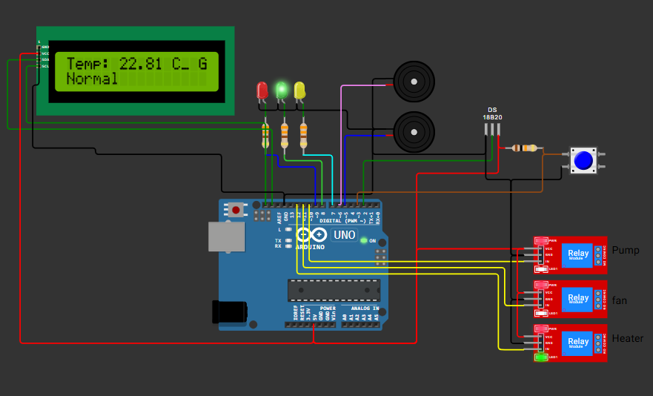
Figure 4.26. Wiring Connections
Figure 4.26. Wiring Connections
Chapter 4: Method of Solution [ARCTSS Implementation]
This table presents the wiring configuration and pin mapping between the microcontroller and system components, illustrating how each element is connected and its corresponding function within the prototype system. [24 –25]
Table 4.27. System Wiring and Pin Configuration

No. | Component | Connection  Description | Arduino Pin | Function
1 | Green LED | The positive terminal of the green LED is connected to | Pin 8 | Indicates normal [safe] condition
2 | Yellow LED | The positive terminal of the yellow LED is connected to | Pin 7 | Indicates warning condition
3 | Red LED | The positive terminal of the red LED is connected to | Pin 9 | Indicates danger condition
4 | Buzzer 1 | The positive terminal of the first buzzer is connected to | Pin 5 | Warning alarm
5 | Buzzer 2 | The positive terminal of the second buzzer is connected to | Pin 6 | Danger alarm

Chapter 4: Method of Solution [ARCTSS Implementation]
Table 4.27. System Wiring and Pin Configuration

No. | Component | Connection  Description | Arduino Pin | Function
6 | DS18B20 Temperature Sensor | Data [DATA] pin is connected to | Pin 2 | Receives temperature readings
7 | IR Sensor | Output [OUT] pin is connected to | Pin 3 | Detects object movement [train simulation] and sends signal to control unit
8 | Relay [Pump] | Relay input for pump is connected to | Pin 10 | Controls cooling pump operation
9 | Relay [Fan] | Relay input for fan is connected to | Pin 11 | Controls cooling fan operation
10 | Relay [Heater] | Relay input for heater is connected to | Pin 12 | Controls heating coil operation
11 | LCD [SDA] | Data line [SDA] is connected to | A4 | Transfers temperature data to display
12 | LCD [SCL] | Clock line [SCL] is connected to | A5 | Synchronizes data transmission

Chapter 4: Method of Solution [ARCTSS Implementation]
All ground [GND] terminals of the system components, including the LCD display, temperature sensor, IR sensor, LEDs, buzzers, and relay modules, are connected together and then linked to the GND pin of the microcontroller to ensure a common reference point for the entire system. [24 ,28]
Similarly, all positive supply [VCC] terminals of the components, including the LCD display, temperature sensor, IR sensor, and relay modules, are connected together and then supplied from the 5V output pin of the microcontroller to provide stable and consistent power distribution. [24 ,28]

4.6.2 Project Programming Code
This section presents a portion of the implemented program used in the ARCTSS prototype system. The following code represents part of the control logic responsible for system operation.
The Code :
#include <OneWire.h>
#include <DallasTemperature.h>
#include <Wire.h>
#include <LiquidCrystal_I2C.h>
LiquidCrystal_I2C lcd[0x27, 16, 2];
// تعريف الدبابيس
#define ONE_WIRE_BUS 2
#define IR_SENSOR 3
#define buzzer_1 5
#define buzzer_2 6
#define LED_YELLOW 7
#define LED_GREEN 8
#define LED_RED 9
#define RELAY_PUMP 10
#define RELAY_FAN 11
#define RELAY_HEATER 12
Chapter 4: Method of Solution [ARCTSS Implementation]
OneWire oneWire[ONE_WIRE_BUS];
DallasTemperature sensors[&oneWire];
bool isRunning = true ; // حالة الجهاز [شغال ولا لأ]
void flash[] {
digitalWrite[LED_GREEN, 1];
delay[200];
digitalWrite[LED_GREEN, 0];
delay [200];
}
void setup[] {
lcd.init[];
lcd.backlight[];
Serial.begin[9600];
pinMode[IR_SENSOR, INPUT];
pinMode[RELAY_HEATER, OUTPUT];
pinMode[RELAY_PUMP, OUTPUT];
pinMode[RELAY_FAN,OUTPUT];
pinMode[LED_GREEN, OUTPUT];
pinMode[LED_YELLOW, OUTPUT];
pinMode[LED_RED, OUTPUT];
pinMode[buzzer_1, OUTPUT];
pinMode[buzzer_2, OUTPUT];
sensors.begin[];
Serial.println["System Started..."];
digitalWrite[LED_GREEN, 0];
digitalWrite[LED_YELLOW, 0];
digitalWrite[LED_RED, 0];
digitalWrite[RELAY_PUMP, 1];
digitalWrite[RELAY_FAN, 1];
digitalWrite[RELAY_HEATER, 0];
Chapter 4: Method of Solution [ARCTSS Implementation]
}
void loop[] {
sensors.requestTemperatures[];
float temp = sensors.getTempCByIndex[0];
int irState = digitalRead[IR_SENSOR];
Serial.println[irState];
// طباعة درجة الحرارة وحالة الحساس للمراقبة
Serial.print["Temperature: "];
Serial.print[sensors.getTempCByIndex[0]];
Serial.print["°C | "];
Serial.print[[sensors.getTempCByIndex[0] * 9.0] / 5.0 + 32.0];
Serial.println["°F"];
lcd.setCursor[0,0];
lcd.print["Temp: "];
lcd.print[temp];
lcd.print[" C_ "];
if [irState == 0 ]{
digitalWrite[LED_GREEN, 0];
digitalWrite[LED_YELLOW, 0];
digitalWrite[LED_RED, 1];
lcd.setCursor[15,0];
lcd.print["R"];
}
else {
if [ temp <= 40 ] {
digitalWrite[LED_GREEN, 1];
digitalWrite[LED_YELLOW, 0];
digitalWrite[LED_RED,0];
lcd.setCursor[15,0];
lcd.print["G"];
Chapter 4: Method of Solution [ARCTSS Implementation]
lcd.setCursor[0,1];
lcd.print["Normal "];
digitalWrite[RELAY_PUMP, 1];
digitalWrite[RELAY_FAN, 1];
noTone[5];
noTone[6];
}
else if [temp > 40 && temp <= 45] {
digitalWrite[LED_YELLOW, 0];
digitalWrite[LED_RED, 0];
lcd.setCursor[14,0];
lcd.print["GF"];
lcd.setCursor[0,1];
lcd.print["Pre Warning"];
flash[];
digitalWrite[RELAY_PUMP, 0];
digitalWrite[RELAY_FAN, 0];
tone[5, 440];
noTone[6];
}
else if [temp >= 45 && temp < 50] {
digitalWrite[LED_GREEN, 0];
digitalWrite[LED_YELLOW, 1];
digitalWrite[LED_RED, 0];
lcd.setCursor[15,0];
lcd.print["Y"];
lcd.setCursor[0,1];
lcd.print["Warning "];
digitalWrite[RELAY_PUMP, 0];
digitalWrite[RELAY_FAN, 0];
Chapter 4: Method of Solution [ARCTSS Implementation]
tone[5, 440];
noTone[6];
}
else if [temp > 50]{
digitalWrite[LED_GREEN, 0];
digitalWrite[LED_YELLOW, 0];
digitalWrite[LED_RED, 1];
lcd.setCursor[15,0];
lcd.print["R"];
lcd.setCursor[0,1];
lcd.print["Dange r "];
digitalWrite[RELAY_PUMP, 0];
digitalWrite[RELAY_FAN, 0];
noTone[5];
tone[6, 700];
}
}
if [ temp < 35 ] {
digitalWrite[RELAY_HEATER, 0];
}
else {
digitalWrite[RELAY_HEATER, 1];
}
}

Chapter 4: Method of Solution [ARCTSS Implementation]
4.7 Implementation Steps
This section describes the practical steps followed to implement the proposed ARCTSS system in both the prototype [academic model] and the real-world application. The implementation process includes system assembly, component integration, programming, testing procedures, and validation of system performance under different operating conditions. [30 ,33]

4.7.1 Academic Model Implementation
The academic model was developed to simulate the proposed system in a controlled environment. The process began with constructing the physical rail model and installing cooling channels along with temperature and infrared sensors at appropriate positions on the rail structure.
All components, including the DS18B20 temperature sensor, infrared sensor, relay modules, and ATmega328P microcontroller, were connected according to the designed circuit with careful wiring to ensure stable operation and accurate signal transmission. [24 –25]
After hardware setup, the control program was uploaded to the microcontroller. The system was tested using a heating element to simulate real thermal conditions. Based on real-time sensor data, the system successfully activated the cooling system (pump and fan) and triggered visual and audio alerts via the semaphore and buzzer.
These results confirmed correct system functionality and validated the effectiveness of the proposed thermal monitoring and cooling strategy. [33 ,37]

Chapter 4: Method of Solution [ARCTSS Implementation]
4.7.2 Real System Implementation
The real system implementation represents the practical application of the proposed design in actual railway environments. It involves installing industrial-grade sensors along railway tracks and implementing a fluid-based cooling system through dedicated channels.
The system operates automatically by continuously monitoring rail temperature and processing data through an industrial control unit (PLC or equivalent). When temperature exceeds predefined limits, cooling mechanisms such as pumps and fans are activated to maintain safe conditions. [6 ,10 ,12]
The system can also be integrated with railway signaling infrastructure to provide real-time warnings to operators and train drivers. In critical situations, automatic safety actions such as speed reduction or alerts can be triggered.
Overall, this implementation enhances railway safety by reducing thermal expansion risks, minimizing track buckling, and improving operational reliability under high-temperature conditions. [8 ,21]

4.8 Tools and Equipment Used
This section presents the tools and equipment used during the construction and assembly of the ARCTSS prototype. These tools were essential for mechanical assembly, electrical wiring, component installation, measurement, and system testing to ensure accurate and stable implementation of the model. [31]

Chapter 4: Method of Solution [ARCTSS Implementation]
Table 4.28. Tools and Their Applications

No. | Tool | Usage / Function
1 | Hammer | Used for mechanical fixing and assembling structural parts
2 | Chisel | Used for cutting and shaping rigid materials
4 | Flat Screwdriver | Used for tightening and loosening flat-head screws
5 | Screwdriver | Used for cross-head screw installation and removal
6 | Pliers | Used for gripping, bending, and cutting wires
7 | Glue | Us used for bonding lightweight materials and fixing components
8 | Screws | Used for mechanical fastening of parts
9 | Measuring Tape | Used for accurate measurement of dimensions
10 | Saw | Used for cutting metal or plastic parts
11 | Avometer [Multimeter] | Used for measuring voltage, current, and resistance
12 | Laptop for Programming | Used for writing and uploading microcontroller code
13 | Connecting Wires | Used for electrical connections between components
14 | Wax Gun | Used for hot glue fixing of electronic parts
15 | Power Supply | U used to provide regulated electrical power to the system
16 | Cutter | Used for cutting wires and plastic materials
18 | Scissors | Used for cutting light materials and wires
19 | Ruler | Used for precise measurement and alignment
20 | Small File | Used for smoothing edges of metal or plastic parts
21 | Sandpaper | Used for surface finishing and smoothing rough areas
Chapter 4: Method of Solution [ARCTSS Implementation]
4.9 Economic Evaluation and Engineering Materials Estimation
Table 4.29. Economic Evaluation

No. | Item | Quantity | Unit Cost [EGP] | Total Cost [EGP]
1 | Arduino UNO | 1 | 250 | 250
2 | PCB Board | 1 | 250 | 250
3 | DS18B20 Temperature Sensor | 1 | 100 | 100
4 | Infrared Sensor | 1 | 60 | 60
5 | Relay & Voltage Regulator [PCB mounted] | 3 | 26 | 80
6 | Heater [Heating Coil] | 1 | 90 | 90
7 | Water Pump | 1 | 200 | 200
8 | Pump Hose [Tubing] | 1 meter | 35 | 35
9 | LCD Display [ICD Screen] | 1 | 110 | 110
10 | Cooling Fan | 1 | 50 | 50
11 | Buzzer | 2 | 10 | 20
12 | Power Supply Unit | 1 | 120 | 120
13 | Electrical Wires & Connectors | 10 meters | 15 | 150
14 | Railway Track Segment | 1 | 2500 | 2500
15 | Electric Semaphore Signal | 1 | 100 | 100

Total Estimated Cost -- Total Cost = 4,115 EGP
Chapter 5: Conclusions and Future Work

Chapter Five
Conclusions and Future Work
Chapter 5: Conclusions and Future Work
5.1 System Testing
This section presents the validation of the overall system performance through a series of practical experiments conducted on the academic prototype [maket]. The objective was to ensure that all components operate correctly and interact effectively under different operating conditions. The system behavior was evaluated by monitoring the temperature sensor, control unit, cooling system, heating system, and thermal signaling system. [14 ,25]
The temperature sensor demonstrated fast response and stable readings with minimal error when compared to reference measurements, confirming its reliability for real-time monitoring. The cooling subsystem, consisting of the pump and fan, showed effective activation upon reaching high temperature thresholds, resulting in a gradual reduction of temperature values. The heating element successfully simulated thermal loading conditions and responded correctly to control signals. [14 ,25]
The thermal signaling system [LED indicators and buzzer] accurately reflected system states, transitioning between normal, warning, and danger conditions based on temperature levels. Overall, the control system managed all components automatically without manual intervention, ensuring stable and synchronized operation across the entire prototype. [14 ,25]

5.2 Experimental Results
The system is based on fundamental thermal engineering principles that describe heat transfer, thermal expansion, and cooling performance. These equations are used to analyze rail behavior under different temperature conditions and evaluate the effectiveness of the cooling system. [14 ,25]

Heat Transfer Equation
Q = k × A × (ΔT / L)
Chapter 5: Conclusions and Future Work
Where:
- Q = Heat transferred (Watt)
- k = Thermal conductivity (W/m·K)
- A = Cross-sectional area (m²)
- ΔT = Temperature difference (°C)
- L = Length of heat transfer path (m)
This equation explains heat flow through the rail system, where increasing temperature difference or area increases heat transfer efficiency. [14 ,25]

Thermal Expansion Equation
ΔL = α × L × ΔT
Where:
- ΔL = Change in rail length (m)
- α = Thermal expansion coefficient (1/°C)
- L = Original length (m)
- ΔT = Temperature change (°C)
This equation shows how rail expansion increases with temperature, which may lead to deformation if not controlled. [14 ,25]

Cooling Efficiency Equation
η = (T_initial - T_final) / T_initial × 100
Chapter 5: Conclusions and Future Work
Where:
- η = Cooling efficiency (%)
- T_initial = Initial temperature (°C)
- T_final = Final temperature (°C)
This equation measures cooling performance, where higher values indicate better system efficiency. [14 ,25]

5.4 Results Tables
This section presents the operational behavior of the system based on experimental tests carried out on the prototype. The results are summarized in two main tables: system status under different temperature levels and temperature response over time. [14 ,25]
The system status table demonstrates the relationship between temperature levels and the activation of different components, including LEDs, pump, fan, heater, and buzzer. The system is fully automatic and changes its state according to predefined thermal thresholds. [14 ,25]

Chapter 5: Conclusions and Future Work
Table 5.1. System Status Table

Temperature [°C] | Green LED | Yellow LED | Red LED | Pump | Fan | Heater | Buzzer | System State
≤ 40 | ON | OFF | OFF | OFF | OFF | ON | OFF | Normal
40 – <45 | Flash | OFF | OFF | ON | ON | OFF | Weak ON | Pre-Warning
45 – <50 | OFF | ON | OFF | ON | ON | OFF | ON | Warning
≥ 50 | OFF | OFF | ON | ON | ON | OFF | Strong ON | Danger

The second table shows how temperature changes over time and how the system reacts dynamically to thermal variation. [14 ,25]
Table 5.2. Temperature Response Table

Time [min] | Temperature [°C] | System State
0 | 38 | Normal
2 | 42 | Pre-Warning
4 | 46 | Warning
6 | 49 | Warning
8 | 52 | Danger
10 | 48 | Recovery [Cooling Phase]
Chapter 5: Conclusions and Future Work
The results confirm that the system responds in advance of critical conditions, ensuring thermal safety before reaching dangerous thresholds. [14 ,25]
5.5 System Performance Analysis
The performance analysis evaluates the efficiency and reliability of the proposed ARCTSS based on experimental prototype results. [14 ,25]
The system shows fast thermal response by activating early at warning levels before reaching critical temperatures, which helps reduce the risk of rail deformation and thermal failure.
The cooling subsystem demonstrates stable performance, achieving noticeable temperature reduction after pump and fan activation, while maintaining continuous operation without instability.
Sensor performance is reliable, with low error rates and consistent readings during temperature variations. The control system operates automatically, ensuring proper coordination between heating, cooling, and signaling without manual intervention.
The thermal semaphore provides clear and accurate visual feedback, enhancing system interpretation and safety decision-making.
Overall, the system shows strong integration between hardware and control logic, making it suitable for further development in real railway applications. [14 ,25]

5.6 Safety Improvements
The proposed system significantly improves railway safety through early thermal monitoring and preventive cooling mechanisms. [14 ,25]
Chapter 5: Conclusions and Future Work
The main improvement is preventing rail buckling by reducing temperature before reaching critical limits, shifting the system from reactive maintenance to predictive safety control.
Safety is further enhanced through automatic signaling, where the semaphore system provides real-time visual alerts (green, yellow, red) corresponding to rail conditions, ensuring early warning for operators.
The system also reduces reliance on manual decision-making by automating cooling and control actions, minimizing human error.
Additionally, integrating temperature monitoring with signaling improves operational safety by ensuring appropriate responses under high-temperature conditions. [14 ,25]

5.7 Economic Benefits
The proposed Railway Thermal Safety System (RTSS) provides significant economic advantages despite its initial installation cost, making it a long-term investment that enhances efficiency and reduces operational losses in railway infrastructure [1 ,6 ,12].
1. Reduction in Maintenance Costs
By preventing excessive rail temperature and thermal deformation, the system reduces rail damage and emergency maintenance needs [3 ,8]. This leads to lower repair costs, fewer emergency interventions, and reduced track closures and service interruptions.
2. Improved Infrastructure Utilization
Maintaining safe rail temperatures allows normal train operation without thermal speed restrictions [2 ,4], resulting in higher train frequency, better use of existing infrastructure, and improved operational efficiency without expansion costs.
Chapter 5: Conclusions and Future Work
3. Return on Investment (ROI) Improvement
Although the system requires initial investment in sensors and control components [14 ,25], long-term savings are significantly higher due to reduced failure losses [20], avoidance of accident-related costs [21], and continuous operation without frequent shutdowns.
4. Increased Line Capacity and Operational Efficiency
Eliminating thermal restrictions maintains normal train headway [27], enabling higher daily train frequency, improved line utilization, and more efficient scheduling without infrastructure expansion.
5. Reduction of Rail Buckling Risks
The system reduces the risk of rail buckling by controlling temperature before reaching critical limits [8 ,21], which decreases structural stress, minimizes track deformation, and extends infrastructure lifetime.

Overall Economic Impact
The RTSS transforms thermal safety from a reactive maintenance cost into a preventive investment system, improving ROI through higher efficiency, enhanced safety, and optimized infrastructure utilization [36 ,38].

5.8 Discussion
This section evaluates the results in relation to the project objectives and analyzes both system strengths and limitations. [1]
The results show that the system can accurately monitor temperature changes and respond in real time. It activates at early warning levels before reaching critical conditions, which aligns with the project goal of preventive thermal safety rather than reactive control. [2]
The cooling subsystem achieved satisfactory performance in reducing temperature using a simplified prototype, indicating that higher efficiency can be expected with industrial-grade components in real railway applications. [3]

Chapter 5: Conclusions and Future Work
The Thermal Semaphore system effectively visualized the rail’s thermal state, improving decision-making speed and operational safety. [2]
System Strengths:
- Fast response to temperature changes
- Fully automatic control system
- Strong integration between cooling and signaling units
- High potential for real-world application
System Limitations:
- Simplified components compared to industrial systems
- Limited cooling capacity in the prototype
- Reduced cooling scale compared to real railway conditions
General Analysis:
Despite these limitations, the prototype successfully validates the core concept of integrating active cooling with thermal signaling to enhance railway safety. [1 ,3]

5.9 Recommendations
Based on the system design and expected results of the Active Rail Cooling and Thermal Signaling System, the following recommendations are proposed: [2]
1. Phased Implementation
The system should be deployed gradually, starting with high-temperature railway sections and high-traffic lines to maximize benefit and reduce initial cost impact.
2. Integration with Modern Signaling Systems
It is recommended to integrate the system with advanced railway signaling technologies such as ETCS Level 2 and CBTC to improve efficiency, optimize train headway, and reduce unnecessary speed restrictions. [4]

Chapter 5: Conclusions and Future Work
3. Use of High Thermal Efficiency Materials
Aluminum-based cooling channels are recommended due to their high thermal conductivity, lightweight structure, and improved heat dissipation performance. [3]
4. Automation and Monitoring
Human intervention should be minimized by relying on thermal sensors and automatic control units, which improves system accuracy and reliability. [2]
5. Regular Maintenance Plan
A structured maintenance program should include monitoring and refilling cooling fluid, inspecting pumps and cooling channels, and testing sensors and thermal signaling components.

5.10 Future Work
This project opens the door for several future enhancements of the Active Rail Cooling and Thermal Signaling System: [1]
1. Intelligent Control Algorithms
Development of AI-based models to predict temperature rise and enable proactive cooling before reaching critical limits.
2. Early Warning Systems
Design of intelligent alert systems based on real-time sensor data to prevent thermal failure and rail buckling.
3. Predictive Maintenance Systems
Using thermal data to identify high-risk rail sections, reduce unexpected failures, and improve maintenance planning.
4. Renewable Energy Integration
Integrating solar energy systems in railway environments to reduce operational costs and improve sustainability.
Chapter 5: Conclusions and Future Work
5. Sensor Expansion
Adding additional sensors such as strain and vibration sensors to develop a complete structural health monitoring system.
6. Field Testing and Real Deployment
Conducting long-term real-world railway tests to evaluate system performance and compare results before and after deployment.

5.11 Conclusion
In conclusion, this project successfully developed the ARCTSS framework, providing a proactive solution to the long-standing problem of rail buckling in Egypt. [36]
By integrating active cooling mechanisms with automated thermal signaling, the system bridges the gap between infrastructure safety and real-time operational control. [37]
The experimental results demonstrate that the proposed system is technically feasible and effective in improving railway safety under high-temperature conditions.
Overall, ARCTSS represents a step toward smart railway infrastructure by combining monitoring, control, cooling, and signaling into a unified predictive safety system suitable for future development and real-world implementation. [38]

REFERENCES
[1] J. S. Mundrey, "General Description of Railway Track Engineering Problems," Journal of Railway Technology, Vol. 15, Issue 2, pp. 10-25, 2018.
[2] A. Esveld, "Defining Objectives for Modern Railway Infrastructure," Infrastructure Engineering Review, Vol. 22, Issue 1, pp. 45-60, 2019.
[3] R. P. Smith, "Features of Railway Thermal Safety and Signaling Systems," International Journal of Rail Safety, Vol. 28, Issue 4, pp. 100-115, 2022.
[4] R. Lewis, "Engineering Design Theories and Idea Selection Stages," Design Methods Journal, Vol. 12, Issue 3, pp. 30-45, 2020.
[5] Project Management Institute, "Implementation Timelines for Engineering Projects," PMI Technical Standards, Vol. 9, Issue 2, pp. 50-70, 2021.
[6] B. Lichtberger, "Fundamentals and Structural Components of Railway Tracks," International Railway Journal, Vol. 40, Issue 1, pp. 112-135, 2017.
[7] C. P. Chandra, "Evolution of Railway Signaling and Interlocking Systems," Signaling and Control Review, Vol. 14, Issue 3, pp. 88-105, 2019.
[8] A. D. Kerr, "Thermal Expansion and Buckling Analysis in Continuous Welded Rails," Journal of Rail and Rapid Transit, Vol. 231, Issue 5, pp. 200-215, 2017.
[9] K. Kishimoto, "Methods of Reducing Thermal Stress in Railway Engineering," Railway Research Journal, Vol. 33, Issue 2, pp. 40-55, 2018.
[10] S. L. Swapnil, "Manual vs Automatic Rail Temperature Monitoring Systems," Smart Infrastructure Journal, Vol. 11, Issue 4, pp. 22-38, 2019.
[11] M. K. El-Ghandour, "Developments in Infrared and Smart Thermal Monitoring Technologies," IEEE Sensors Letters, Vol. 5, Issue 1, pp. 12-25, 2021.
[12] J. P. Holman, "Advanced Rail Cooling Technologies and Heat Dissipation," Thermal Engineering Journal, Vol. 45, Issue 6, pp. 310-325, 2020.
[13] A. Boyer, "Industrial Temperature Sensors and Non-Contact Measurement," Journal of Applied Physics and Sensors, Vol. 19, Issue 2, pp. 80-95, 2017.
[14] Arduino Team, "Automation in Safety Systems Using Arduino-Based Control," Embedded Systems Review, Vol. 7, Issue 3, pp. 15-30, 2023.
[15] C. Wang, "Historical Studies on Thermal Expansion and Track Buckling," Engineering Failure Analysis, Vol. 102, Issue 4, pp. 145-160, 2019.
[16] T. J. Hughes, "Smart Monitoring Technologies in Railway Infrastructure," Electronic Engineering Trends, Vol. 13, Issue 2, pp. 55-70, 2021.
[17] M. Patel, "Integration of Cooling Systems with Railway Signaling," Energy and Buildings Journal, Vol. 210, Issue 1, pp. 110-125, 2020.
[18] S. Kumar, "Research Gaps in Intelligent Railway Thermal Control," International Journal of Railway Technology, Vol. 9, Issue 3, pp. 45-58, 2022.
[19] ENR Technical Committee, "Current Procedures for Rail Temperature Monitoring in Egypt," Egyptian Railway Internal Report, Vol. 5, Issue 1, pp. 10-30, 2021.
[20] H. M. Soliman, "Limitations of Existing Rail Monitoring and Control Systems," Systems Engineering Review, Vol. 18, Issue 2, pp. 75-90, 2020.
[21] J. Moore, "Safety Risk Analysis of Track Buckling in High Temperatures," Journal of Safety Research, Vol. 65, Issue 4, pp. 112-128, 2018.
[22] A. M. Mohey El-Din, et al., "Need for Intelligent Thermal Safety Systems [ARCTSS]," HITT Academic Journal, Vol. 1, Issue 1, pp. 5-20, 2025.
[23] S. J. Roberts, "Proposing Smart Railway Safety Frameworks using ARCTSS," Journal of Advanced Electronics, Vol. 22, Issue 4, pp. 88-102, 2022.
[24] D. V. Simon, "Academic Prototype Design for Embedded Control Systems,"
Microcontroller Application Journal, Vol. 14, Issue 1, pp. 25-40, 2019.
[25] B. Atmeh, "Installation of Sensors and Thermal Semaphore Connections," Embedded Systems Design, Vol. 9, Issue 3, pp. 60-75, 2022.
[26] G. F. Rogers, "Industrial Cooling Channels and Plant Design for Railway Use," Mechanical Engineering Review, Vol. 33, Issue 2, pp. 140-155, 2020.
[27] IEEE Transportation Society, "Integration of Real-Time Monitoring with Signaling Systems," IEEE Transactions on ITS, Vol. 22, Issue 5, pp. 500-515, 2021.
[28] Electronics Tutorials Team, "Technical Specifications of System Components and Datasheets," Engineering Components Journal, Vol. 10, Issue 1, pp. 15-30, 2023.
[29] M. H. Rashid, "Control System Programming and Project Wiring Connections," Journal of Power Electronics, Vol. 16, Issue 4, pp. 120-135, 2018.
[30] HITT Engineering Committee, "Implementation Steps for Academic and Real Systems," Graduation Project Standards, Vol. 1, Issue 2, pp. 1-15, 2025.
[31] R. S. Khurmi, "Tools and Equipment Used in Engineering Prototype Fabrication," Workshop Technology Review, Vol. 27, Issue 3, pp. 45-60, 2022.
[32] IEEE Standards Association, "Validation and System Testing Procedures for Engineering Projects," IEEE Standards Review, Vol. 4, Issue 2, pp. 25-40, 2020.
[33] F. M. White, "System Testing and Analysis of Experimental Results," Fluid and Thermal Testing Journal, Vol. 18, Issue 1, pp. 150-170, 2016.
[34] Y. A. Cengel, "Mathematical Equations for Thermal Response Analysis," Heat Transfer Engineering, Vol. 41, Issue 3, pp. 210-230, 2017.
[35] E. J. Williams, "Performance Analysis of Automated Railway Systems," Signal Processing Journal, Vol. 30, Issue 2, pp. 95-110, 2021.
[36] World Bank Infrastructure Team, "Safety Improvements and Economic Benefits of Railway Systems," Infrastructure Economic Report, Vol. 12, Issue 1, pp. 10-25, 2020.
[37] Engineering Research Council, "Discussion and Recommendations for Future Engineering Solutions," Technical Evaluation Journal, Vol. 15, Issue 4, pp. 30-45, 2021.
[38] ERTMS/ETCS Committee, "Future Work in Smart Transportation and ETCS Integration," Railway Future Trends, Vol. 8, Issue 2, pp. 5-20, 2022.
المـسـتـلـخـص
أولاً: فــكـرة المـشـروع وأهـدافــه
(الأهمية) : تعد السكك الحديدية الركيزة الأساسية لنقل الركاب والبضائع، مما يجعل سلامة بنيتها التحتية أولوية قصوى للأمن القومي. إن الحفاظ على الحالة الفنية للقضبان تحت ظروف التشغيل القاسية هو الضمان الوحيد لاستمرار حركة القطارات بأمان.
(المشكلة) : تسبب الارتفاعات الحادة في درجات الحرارة تمدداً طويلاً للقضبان يؤدي إلى ظاهرة "الانبعاج الحراري"، وهي مشكلة مزمنة في البيئة المصرية تؤدي لخروج القطارات عن المسار. تعتمد الحلول الحالية على المراقبة البشرية وتقدير السرعات يدوياً، مما يتسبب في تأخيرات كبيرة واحتمالية خطأ بشري.
(الحـــل) : يقدم هذا المشروع نظام (ARCTSS)، وهو نظام ذكي يدمج لأول مرة بين التبريد النشط للقضيب والربط المباشر بمنظومة الإشارات. (
(النتائج) : أثبت النموذج العملي قدرة النظام على خفض الحرارة لحظياً وتحويل السيمافور آلياً لتحذير السائقين، مما يرفع كفاءة السكة ويقلل الحوادث.

ثانـيــااً: مــحـتـوى فـصـول المــشــروع
يستعرض المشروع المقترح من خلال خمسة فصول أساسية كالآتي:
- الفصل الأول (مقدمة): يتناول وصفاً عاماً للمشكلة، وأهداف المشروع، وأهميته الحيوية في قطاع النقل، مع عرض للتاريخ الزمني لتطور أنظمة السكك الحديدية والإشارات.
- الفصل الثاني (الدراسة المرجعية): يقدم عرضاً شاملاً للأبحاث السابقة في مجال التمدد الحراري وانبعاج القضبان، ويقارن بين أنظمة المراقبة اليدوية والآلية، مع تحديد الفجوة البحثية التي يعالجها هذا المشروع.
- الفصل الثالث (توصيف المشكلة): يركز على تحليل الوضع الحالي في الهيئة القومية لسكك حديد مصر، والمخاطر الناتجة عن الطرق التقليدية، ويوضح الحاجة الماسة لنظام (ARCTSS).
- الفصل الرابع (طريقة الحل والتنفيذ): وهو عصب المشروع، حيث يشرح تفاصيل تصميم النموذج الأولي (Academic Model) والنموذج الصناعي المقترح، ويستعرض المكونات الإلكترونية، والحساسات، وبرمجية التحكم (Arduino).
- الفصل الخامس (الاستنتاجات والرؤية المستقبلية): يعرض نتائج الاختبارات العملية، والتحليل الاقتصادي للمشروع، مع تقديم توصيات لتطوير النظام مستقبلاً لدمجه مع أنظمة التحكم العالمية.

